Name:…
Surname: …
Home Schooling 16
Today we revise what we learnt last class about Rules with MUST/MUST´T in unit 1 of Superminds.
- Follow the link and play the games.
https://learnenglishkids.britishcouncil.org/grammar-practice/modals-must-and-mustnt
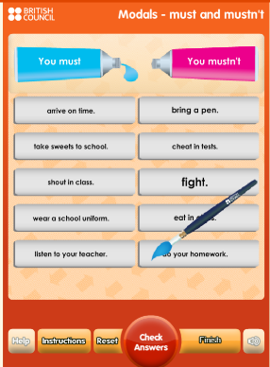
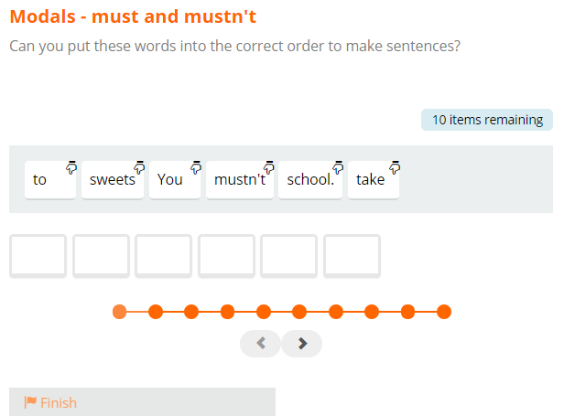

- THIS IS LISA!
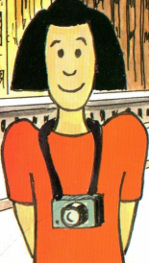
Read the story called “LISA GOES TO LONDON” and answer some questions.

- Look at the picure.
What do you think Lisa and her parents are doing here? …
- Read part one and answer some questions.
PART 1

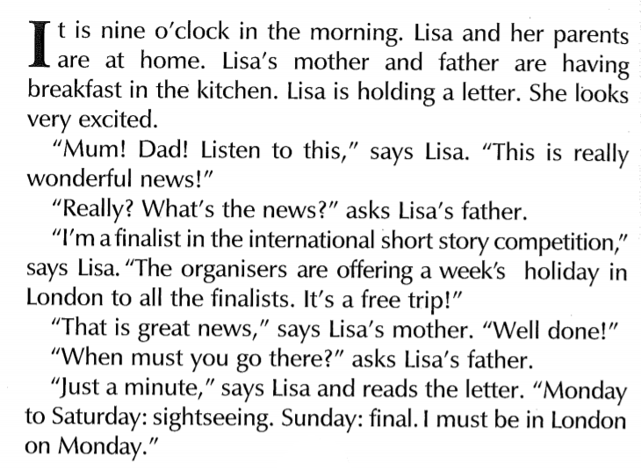
- What are they doing in the kitchen?
…
- What does Lisa tell her parents?
…
- What are the organisers offering to the finalists?
…
- When does she leave?
…
- Complete with MUST or MUSTN’T
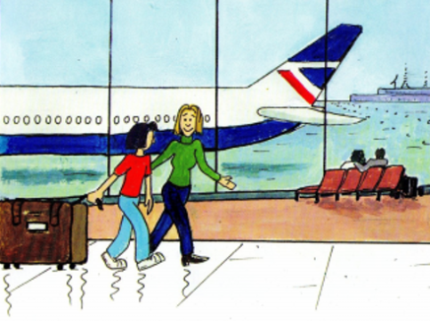
Lisa … be in London on Monday.
- Read part two and write TRUE or FALSE.

PART 2
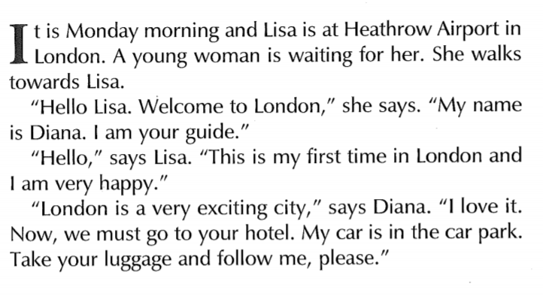

- Lisa must go to the hotel.
…
- This is Lisa’s second time in London.
…
- Lisa must go to the hotel.
…
- Lisa is at Heathrow’s Airport. Help Lisa by filling in this chart what she must or mustn’t do!
USE MUST/MUSTN’T
Lisa … run | 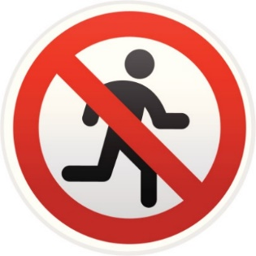
Lisa … bring her passport. | 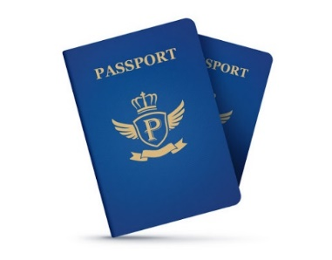
Lisa … get her baggage from the baggage claim area.
Lisa… scan her baggage | 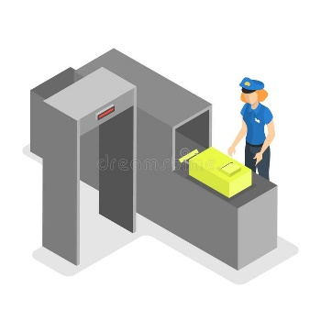
Lisa … bring aerosols in her carry-on luggage.
Lisa … walk through a body scanners | 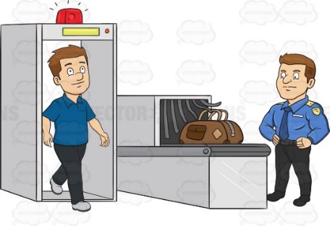

- Think of two more rules and write them down.
- …
- …

This is the end of your file. Check you have solved all the activities, save your work and send it to your teacher via email:
4th Boys: msmicaelaferrero@gmail.com
4th Girls: msgabygar@gmail.com

