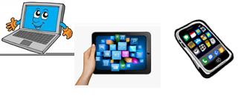
Name:…
Surname: …
Home Schooling 17
To check the past of some verbs, go to ETOOLS4ENGLISH click at: https://bit.ly/2YPN5qj
Today we continue working on unit 1 of Superminds.
- Let’s revise simple past of verbs!

Put the verbs in parenthesis in the simple past tense.
Jim and Sue … (go) to the fast food shop and … (buy) their food. They … (eat) a burger and they … (drink) coke. Later, they … (pay) and … (leave).

Tom … ( have ) a test the next day. He … (take) his books out, … (sit) at his desk and … (study) really hard. He … (pass) the test, of course! | 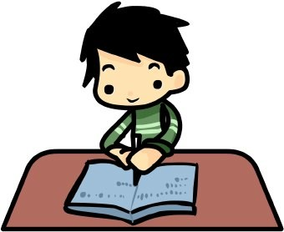

The fire station … (receive) an emergency call. Bob … (shout) to his workmates and he … (ring) the bell. Then they … (jump) in the fire engine and … (set) off.

Joe and Phil … (have) a fun Fight. Joe … (throw) a water bomb and it … (hit) Phil on the head. He … (think) it was funny, so he … (laugh). | 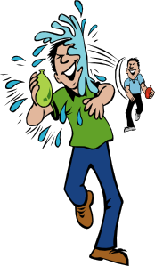

- Do you have any obligations at home?
Now, it’s your time to be creative! Make a short video of your obligations at home in quarantine. You can use toys, teddies or you can record yourself. Include at least 4 sentences using MUST or MUSTN’T.
Have fun! (Send the video to Ms Gaby’s email box)

Example: I must do my home schooling.

1. …
2. …
3. …
4. …

Did you enjoy learning about RULES and OBLIGATIONS? …
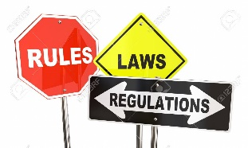

This is the end of your file. Check you have solved all the activities, save your work and send it to your teacher via email:
4th Girls and Boys: msgabygar@gmail.com

NOW GO ONLINE

NOW CLICK AND WORK ONLINE:
https://forms.gle/xgxytawMg5STG3NZ7

PLEASE PRESS “SUBMIT/SEND” AT THE END OF YOUR ONLINE WORK
POR FAVOR PRESIONAR “ENVIAR” AL FINAL DEL TRABAJO EN LINEA

