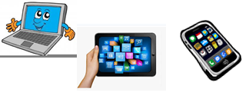
Name:…
Surname: …
Home Schooling 21
Today we start working on UNIT 2 of Superminds!

- Follow the link and find the word “COUNTRYSIDE” in the picture dictionary.
CLICK HERE: http://kids.wordsmyth.net/wild/#/home
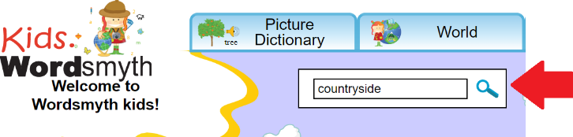

NOW GO ONLINE
NOW CLICK AND WORK ONLINE:
https://forms.gle/tSSEdB9A5hckWy2H8

PLEASE PRESS “SUBMIT/SEND” AT THE END OF YOUR ONLINE WORK
POR FAVOR PRESIONAR “ENVIAR” AL FINAL DEL TRABAJO EN LINEA

