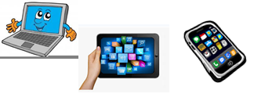
Name:…
Surname: …
Home Schooling 22
Today we continue working on UNIT 2 of Superminds!

- Play the game to revise the new words we learnt in Unit 2.
CLICK HERE: https://thewordsearch.com/puzzle/1181036/

- Look at the picture and write all the words you know.

…

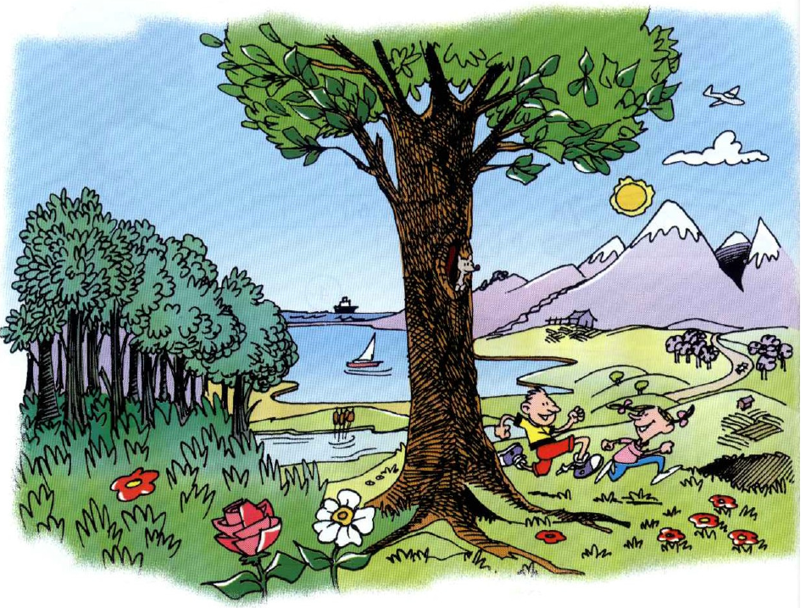

- Follow the link and complete the activities.
CLICK HERE: https://www.liveworksheets.com/pz592557nl

- Follow the link and complete the activity. (Superminds page 23, exercise 1 and 2)
CLICK HERE: https://www.liveworksheets.com/oq592777vj

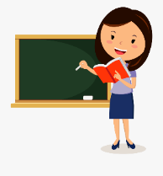
- Ms Mica explains the use of CONNECTORS: AND, BUT ,SO and BECAUSE.
Click on the different links to learn to see the videos:
AND : https://bit.ly/3e7D7oK
BUT: https://bit.ly/2zYVQUN
SO: https://bit.ly/3bYKE7K
BECAUSE: https://bit.ly/36sB2kx

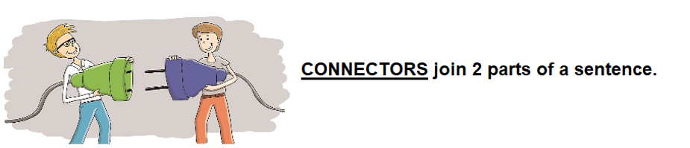
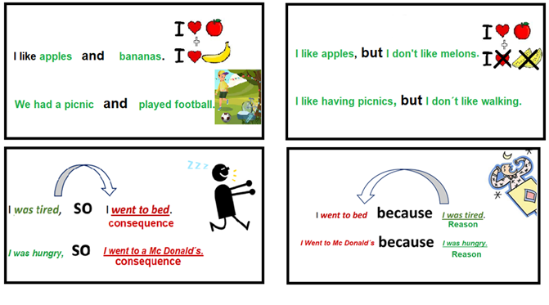
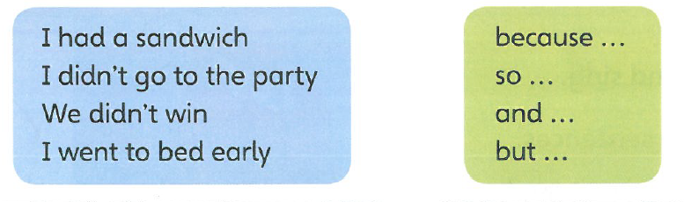
- NOW, WRITE FOUR SENTENCES ABOUT YOU. USE SO, BECAUSE, AND OR BUT

- …

- …

- …

- ...

NOW CLICK AND WORK ONLINE:
https://forms.gle/NhAFotqekMD1VwHq8
PLEASE PRESS “SUBMIT/SEND” AT THE END OF YOUR ONLINE WORK
POR FAVOR PRESIONAR “ENVIAR” AL FINAL DEL TRABAJO EN LINEA

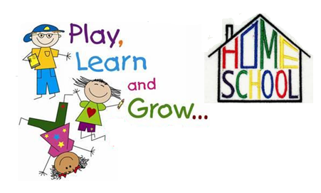

This is the end of your file. Check you have solved all the activities, save your work and send it to your teacher via email:
4th Girls and Boys: msgabygar@gmail.com

