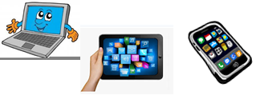
Name:…
Surname: …
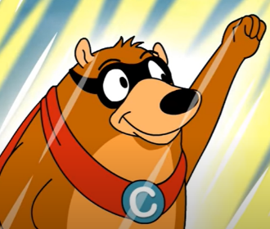
Home Schooling 23
CTRL+CLICK HERE:
https://bit.ly/2Xil6hT
Today we continue working on UNIT 2 of Superminds!

- Watch the video to revise CONJUCTIONS (CONNECTORS) we learnt in Home Schooling 22.

- Join the sentences that appear in the video using SO, BUT, BECAUSE, AND.

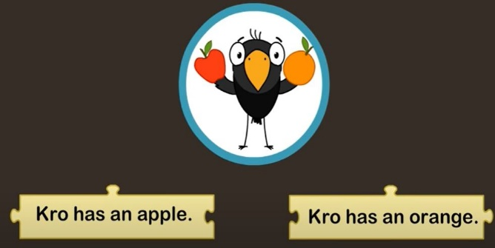 | …
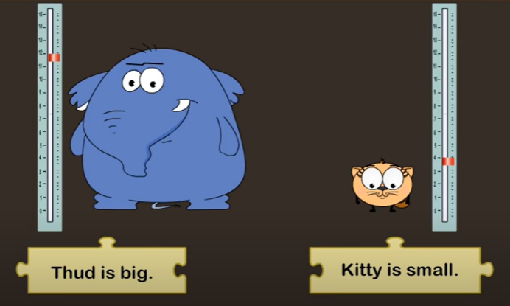 | …

- Follow the link and complete the activities.
CLICK HERE: https://es.liveworksheets.com/tf685605qp

- Use your imagination and write sentences for these pictures using:

…
…
…

NOW GO ONLINE

CTRL+CLICK AND WORK ONLINE:
https://forms.gle/aMMwNGB1myte1JYJ9
PLEASE PRESS “SUBMIT/SEND” AT THE END OF YOUR ONLINE WORK
POR FAVOR PRESIONAR “ENVIAR” AL FINAL DEL TRABAJO EN LINEA

This is the end of your file. Check you have solved all the activities, save your work and send it to your teacher via email:
4th Boys: msmicaelaferrero@gmail.com
4th Girls: msgabygar@gmail.com

