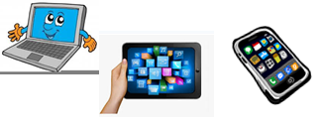
Name:…
Surname: …
Home Schooling 24
Today we continue working on UNIT 2 of Superminds!
1. Write a sentence about yesterday using 1 CONJUNCTION (SO, BUT, BECAUSE, AND)

Eg: Yesterday I was hungry SO I bought a hamburger on Pedidos Ya.

…

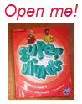
- Open your Superminds on page 24. Look at the pictures and answer.

- Where are they?
…

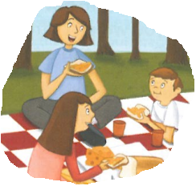 | - What do you eat when you have a picnic?  …
NOW GO ONLINE

CTRL+ CLICK AND WORK ONLINE:
https://forms.gle/XanR4oCN5AfX1YVDA
PLEASE PRESS “SUBMIT/SEND” AT THE END OF YOUR ONLINE WORK
POR FAVOR PRESIONAR “ENVIAR” AL FINAL DEL TRABAJO EN LINEA

This is the end of your file. Check you have solved all the activities, save your work and send it to your teacher via email:
4th Girls and Boys: msgabygar@gmail.com

