Name:…
Surname: …
Home Schooling 25
Today we continue working on UNIT 2 of Superminds!

- Play the game to revise actions.
CLICK HERE: https://www.eslgamesplus.com/action-verbs-esl-interactive-grammar-vocabulary-game-present-tense/
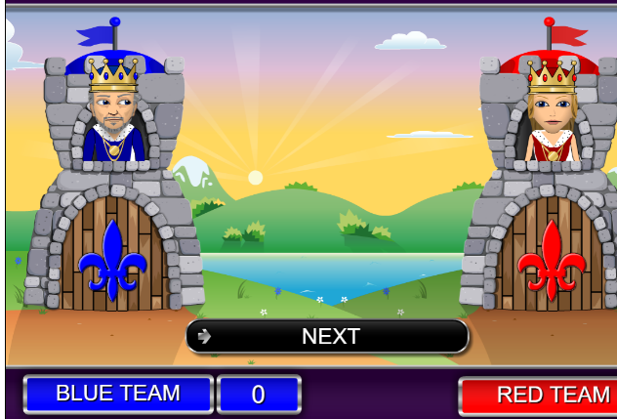

- Play the matching game. Hurry up! There’s a time limit!
CLICK HERE: https://es.educaplay.com/recursos-educativos/5995485-actions.html

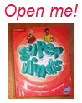
- Let’s work on Superminds (page 25): Listen to grandpa talking to Ben and Lucy about what grandpa could do when he was young.
CLICK HERE: https://www.liveworksheets.com/bi741034ou

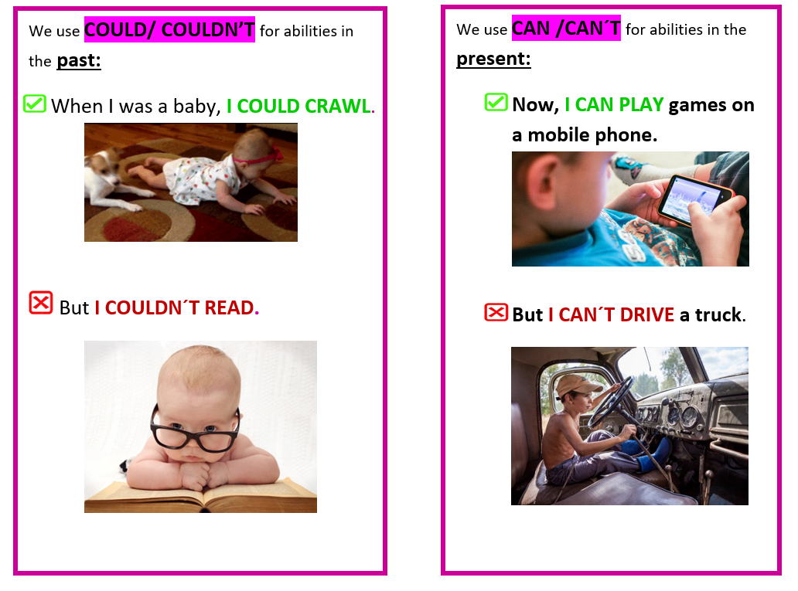
NOW GO ONLINE

CTRL+CLICK AND WORK ONLINE:
https://forms.gle/kxwwRSoTfQAmCEhx9
PLEASE PRESS “SUBMIT/SEND” AT THE END OF YOUR ONLINE WORK
POR FAVOR PRESIONAR “ENVIAR” AL FINAL DEL TRABAJO EN LINEA

