Name:…
Surname: …
Home Schooling 27
Today we continue working on UNIT 2 of Superminds!
- Follow the link and play the game to revise OUTDOOR PLACES:
PRESS CTRL+CLICK TO PLAY

https://bit.ly/2XWriwB
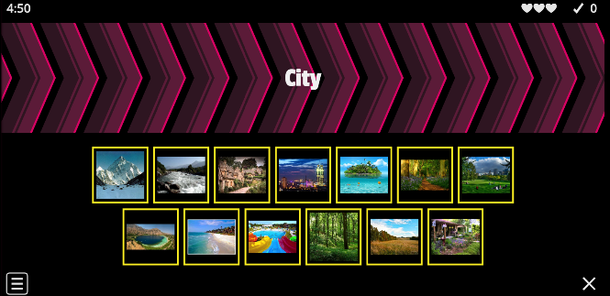

NOW GO ONLINE

CTRL+CLICK AND WORK ONLINE:
https://forms.gle/aELAqV71iX6KpuN69
PLEASE PRESS “SUBMIT/SEND” AT THE END OF YOUR ONLINE WORK
POR FAVOR PRESIONAR “ENVIAR” AL FINAL DEL TRABAJO EN LINEA

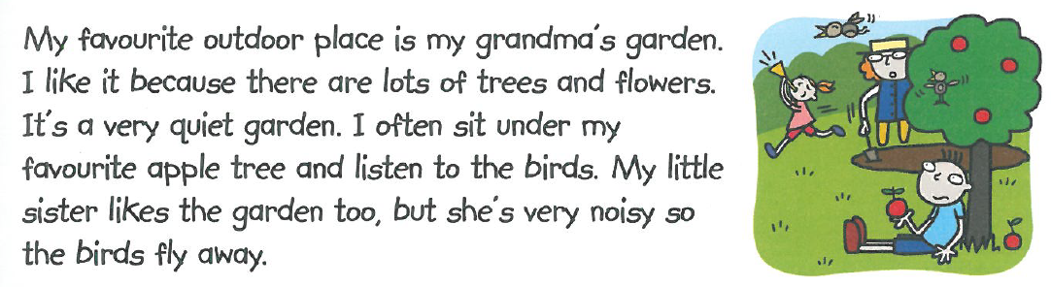
- Read Joshua’s description and answer the questions.
- Where is Joshua’s favourite outdoor place?
…
- Why does he like it so much?
...
- What does he do when he sits under his favourite tree?
…
- Why is his little sister a problem in the garden?
…
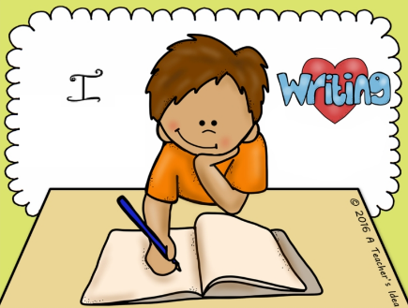
- Write a paragraph about YOUR FAVOURITE OUTDOOR PLACE. (40 - 50 words)
Include:
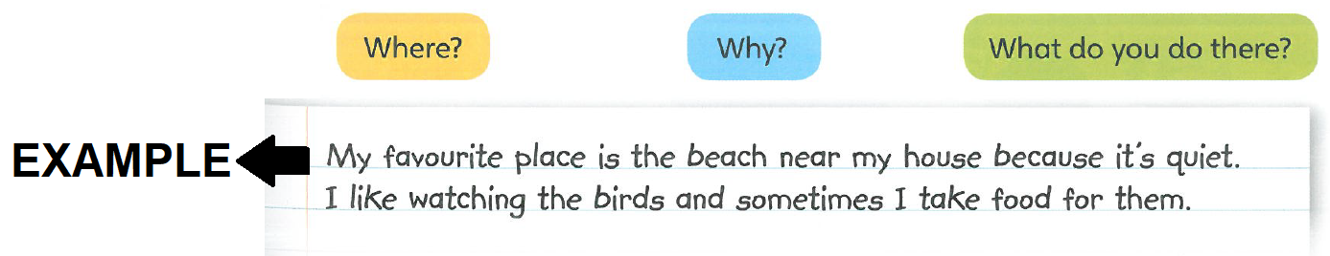

…
This is the end of your file. Check you have solved all the activities, save your work and send it to your teacher via email:
4th Boys: msmicaelaferrero@gmail.com
4th Girls: msgabygar@gmail.com

