Name:…
Surname: …
Home Schooling 28
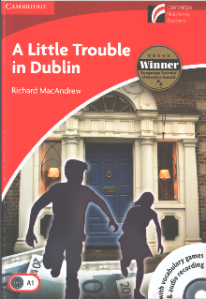
TODAY WE’LL WORK WITH CHAPTER 3 OF OUR READER “A LITTLE TROUBLE IN DUBLIN”.

Let’s revise Chapter 2
“Sometimes I don’t understand my sister,” thought Andy. But he ran out of the hotel with her.

Why does Andy say that?
...
Why did they run out of the hotel?
…

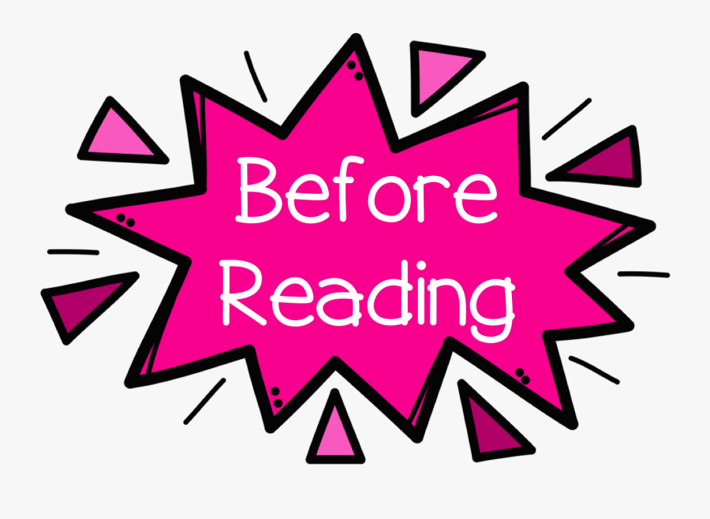
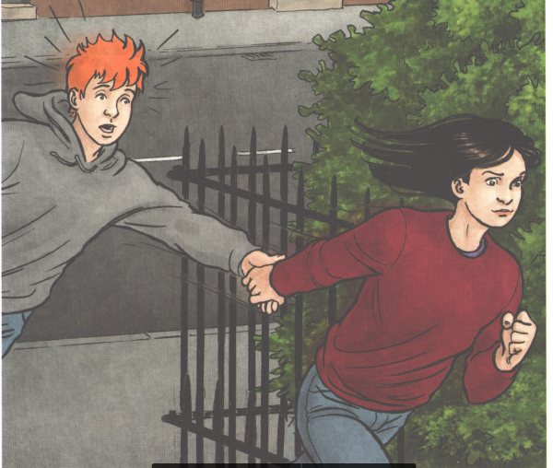
- ANSWER THE QUESTIONS
Where are the twins going?
...

How does Andy feel?
…
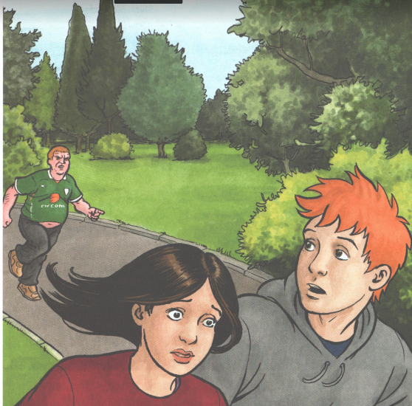
Where do you think the twins are?
...

Why do you think Mr. Green Shirt is running after them?
…
How do the twins feel?
…

- Complete some of the quotes from the story. Use these words: statue - angry - Merrion Square - Run - man - Mr Green Shirt - Come on.
CAREFUL , THERE'S ONE EXTRA!

- “Miss O’Brien’s going to be …, ” said Andy
- “Mary watched the… . He turned right. Andy and Mary ran after him and turned right too.”
- “Next came … . There were houses round the square, and trees and gardens in it.”
- “Andy started to speak but just then the front door opened and … came out. He walked into the gardens.
- “ …,” said Mary. And she and Andy turned and started running. Mr Green Shirt ran after them.”
- “ That’s a … of the famous Irish writer, Oscar Wilde. There’s a picture of it in the hotel.”

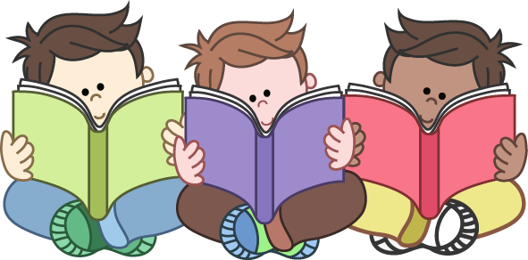

Now, Read or listen to chapter 3!
PDF file: https://bit.ly/3czAvQ0
Audio files: https://bit.ly/2XUCBFj
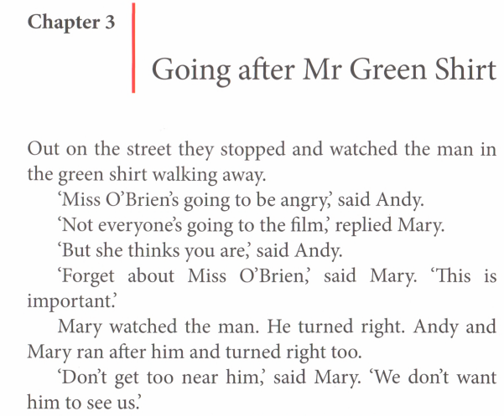

NOW GO ONLINE

CTRL+CLICK AND WORK ONLINE:
https://forms.gle/Dtz7oygBTKUJsJK39
PLEASE PRESS “SUBMIT/SEND” AT THE END OF YOUR ONLINE WORK
POR FAVOR PRESIONAR “ENVIAR” AL FINAL DEL TRABAJO EN LINEA

This is the end of your file. Check you have solved all the activities, save your work and send it to your teacher via email:
4th Boys: msmicaelaferrero@gmail.com
4th Girls: msgabygar@gmail.com

