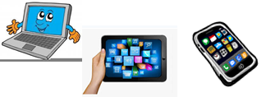
Name:…
Surname: …
Home Schooling 29
Today we finish working on UNIT 2 of Superminds!

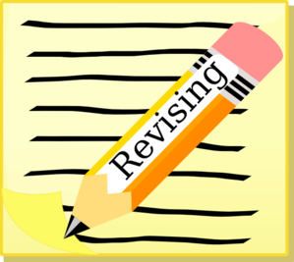
- Open your Superminds on page 120. Follow the link and revise connectors and could/couldn’t.
CLICK HERE: https://www.liveworksheets.com/ey850454yn
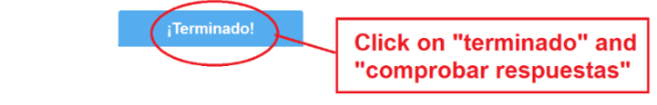

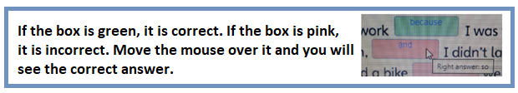

- Follow the link and remember the story in unit 1.

CLICK HERE: https://www.liveworksheets.com/nc849388sd
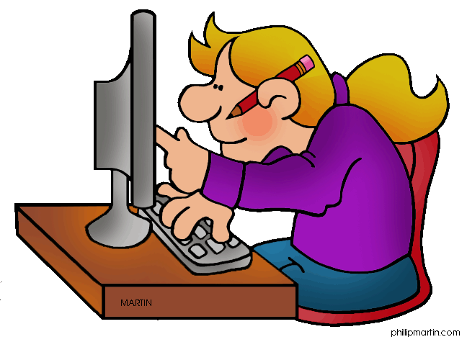

- CLICK AND WORK ONLINE:
https://forms.gle/dfc1Yyu1Szps7uCM6
PLEASE PRESS “SUBMIT/SEND” AT THE END OF YOUR ONLINE WORK
POR FAVOR PRESIONAR “ENVIAR” AL FINAL DEL TRABAJO EN LINEA
