Name:…
Surname: …
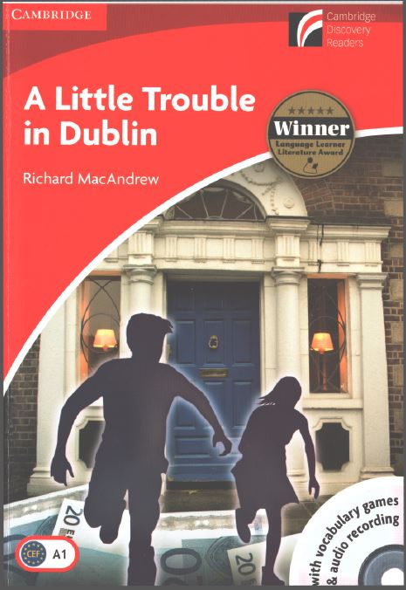
Home Schooling 30
Today we’ll read chapters 4 and 5 of our reader
“A Little Trouble in Dublin”

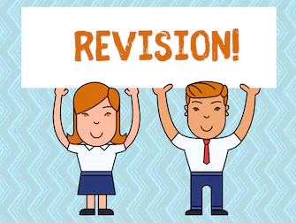

Let’s revise what we read so far!
(Press CTRL AND CLICK AT: https://bit.ly/3dg7gl3 )
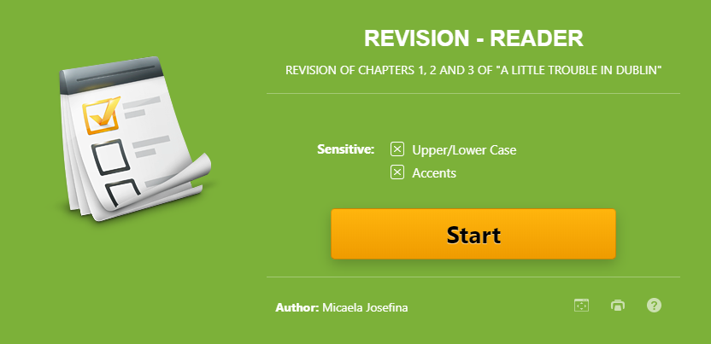

SCORE: ...

BEFORE READING!
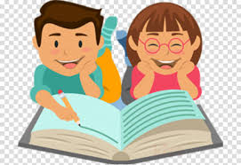
1- What do you think happens in the following chapters? (Write YES or NO)
A- Andy and Mary don’t go to the cinema. ...
B- Miss O’Brien calls the police. ...
C- Andy and Mary see Mr Green Shirt again. ...

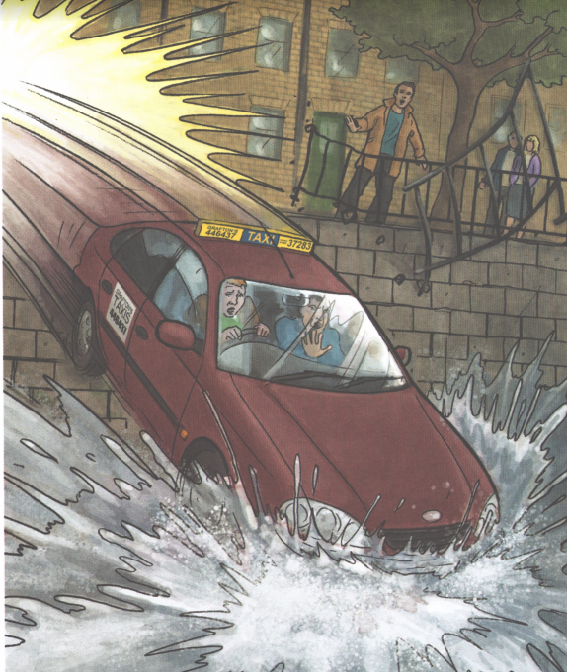
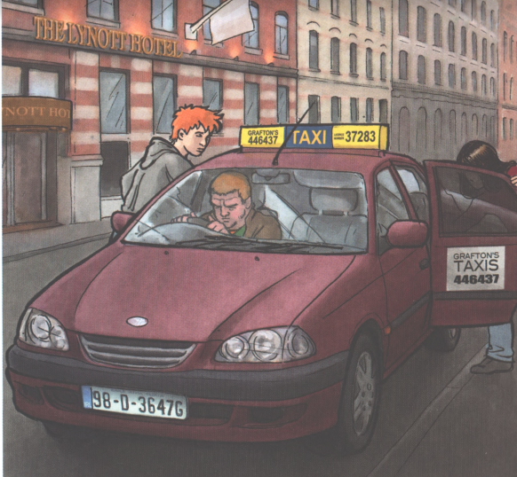
2- Match the pictures to the titles of the chapters. There’s one extra title.

A B

A TAXI TO THE POLICE STATION
A SWIM IN THE RIVER LIFFEY
TALKING TO THE POLICE
Picture A ... | Picture B ...
3- Describe the two pictures in no more than 20 words.
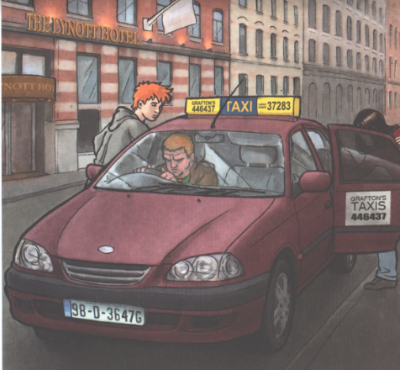 | ...

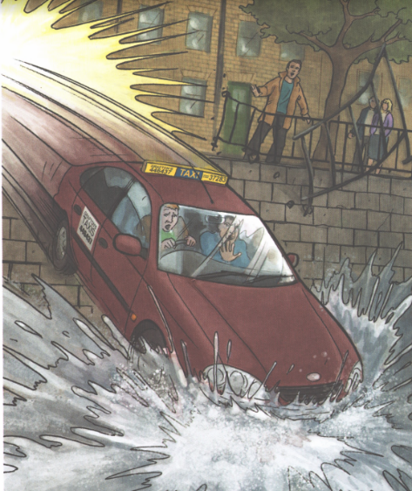 | …
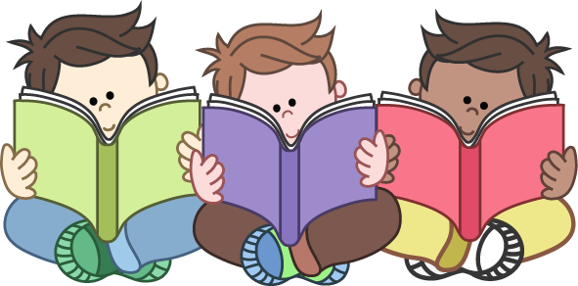
4- Now, listen and/or read chapters 4 and 5!

PDF file: https://bit.ly/3czAvQ0
Audio files Chapter 4: https://bit.ly/2YhsniH
Chapter 5: https://bit.ly/2V1y9mr

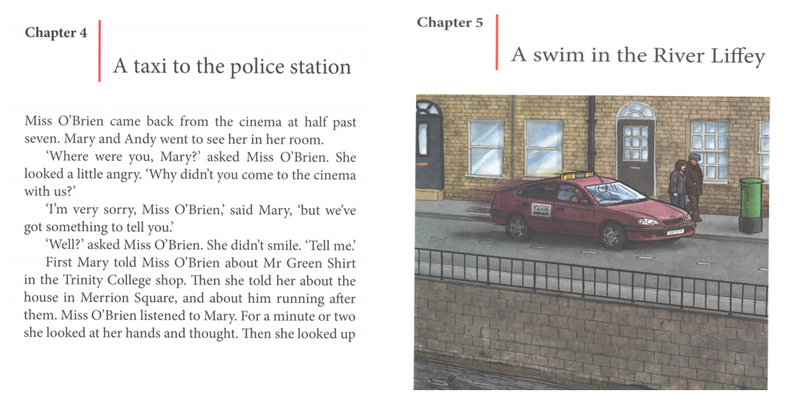

NOW GO ONLINE

CTRL+CLICK AND WORK ONLINE:
https://forms.gle/od5ePuQxhpkyLPFb7
PLEASE PRESS “SUBMIT/SEND” AT THE END OF YOUR ONLINE WORK
POR FAVOR PRESIONAR “ENVIAR” AL FINAL DEL TRABAJO EN LINEA

This is the end of your file. Check you have solved all the activities, save your work and send it to your teacher via email:
4th Boys: msmicaelaferrero@gmail.com
4th Girls: msgabygar@gmail.com

