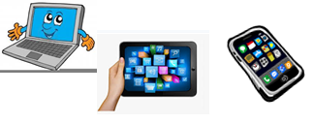
Name:…
Surname: …
Home Schooling 31
Hello again! Today we start working on UNIT 3 of Superminds!

- Ctrl+ click and work online:
https://forms.gle/yVVoeixrQUUydk1n8
PLEASE PRESS “SUBMIT/SEND” AT THE END OF YOUR ONLINE WORK
POR FAVOR PRESIONAR “ENVIAR” AL FINAL DEL TRABAJO EN LINEA

