Name:…
Surname: …
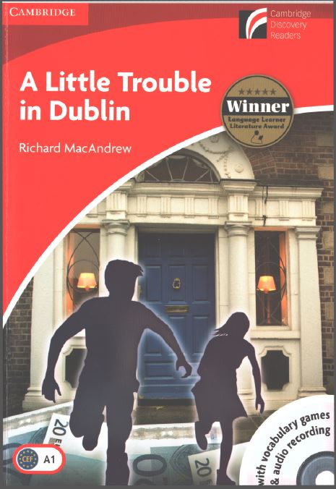
Home Schooling 32
Today we will work on chapter 6 of our reader
“A Little Trouble in Dublin”

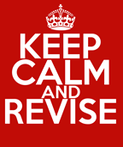

Let’s check what happened in Chapters four and five!

1- Click here: https://bit.ly/3dywafV to do this Quiz! 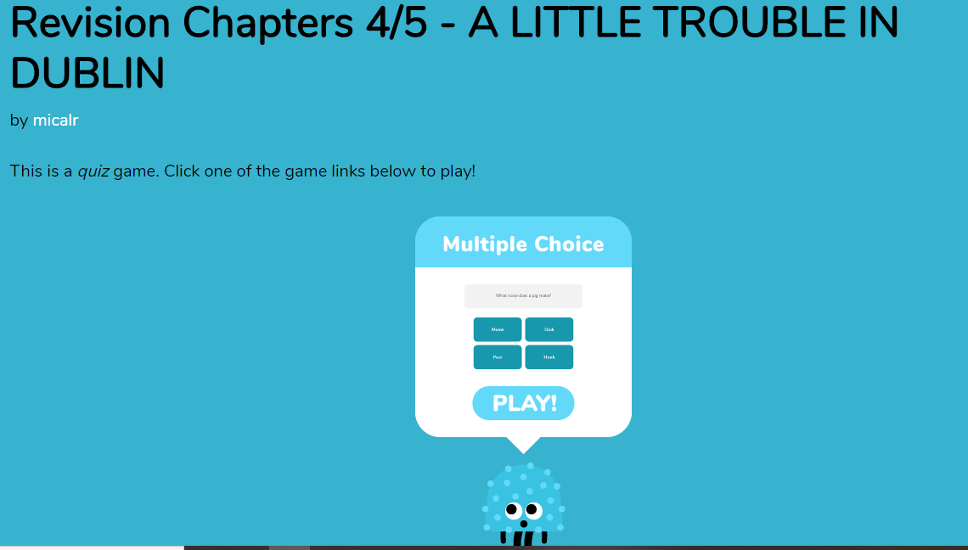
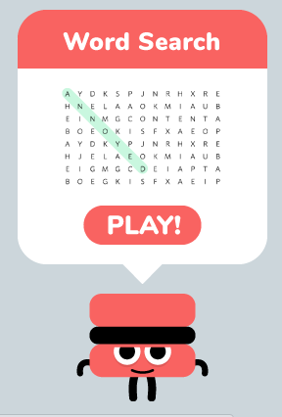
2- Click here: https://bit.ly/3dyd75o to work on this worksheet! When you finish click on “TERMINADO” and then on “COMPROBAR MIS RESPUESTAS”
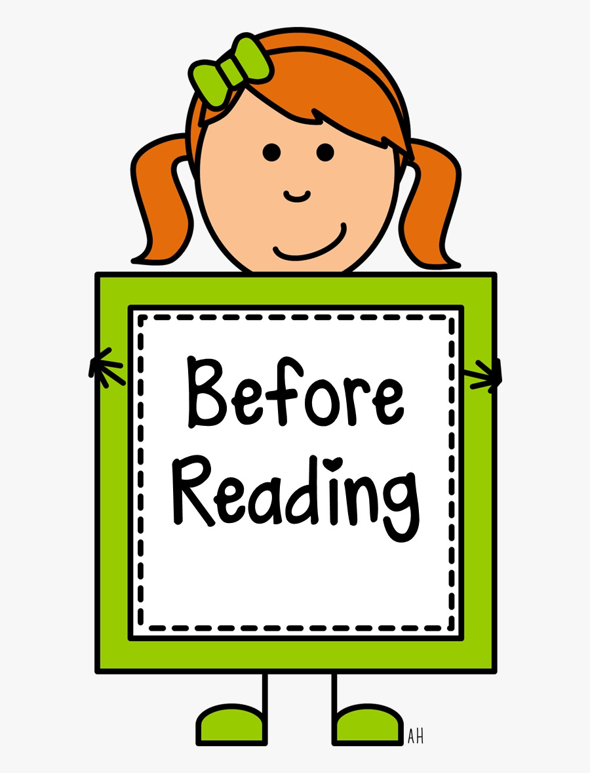

3- Now let’s focus on Chapter 6.
Click here: https://bit.ly/2VgfbZA to solve a wordsearch that contains keywords of the chapter. There are 12 words for you to find.
You can do the anagram, if you want, after the word search.

4- Now, listen/read chapter 6
PDF file: https://bit.ly/3czAvQ0
Audio file: https://bit.ly/3fPL8j0
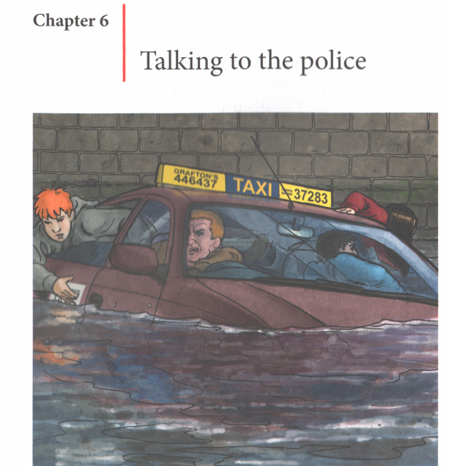
NOW GO ONLINE

CTRL+CLICK AND WORK ONLINE:
https://forms.gle/RDQ7GHu1S3j1PRTz8
PLEASE PRESS “SUBMIT/SEND” AT THE END OF YOUR ONLINE WORK
POR FAVOR PRESIONAR “ENVIAR” AL FINAL DEL TRABAJO EN LINEA

This is the end of your file. Check you have solved all the activities, save your work and send it to your teacher via email:
4th Boys: msmicaelaferrero@gmail.com
4th Girls: msgabygar@gmail.com

