Name:…
Surname: …
Home Schooling 33
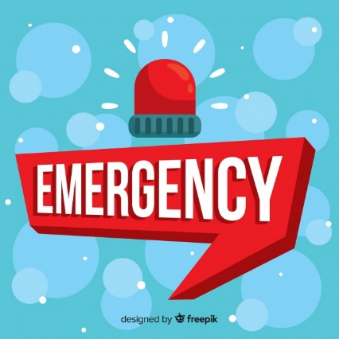
Hello again! Today we keep on working on UNIT 3 of Superminds!
- Follow the link and solve the crossword to revise vocabulary related to EMERGENCY!
CLICK HERE: https://es.educaplay.com/recursos-educativos/6245456-danger.html

- Follow the link and work on page 35 of Superminds.

CLICK HERE: https://www.liveworksheets.com/ua908187tr
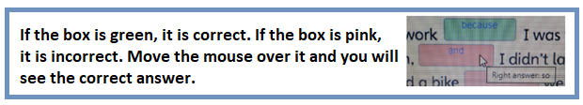

- Watch and listen the video by Ms Gaby and learn the use of Past Continuous.
CLICK HERE: https://www.loom.com/share/7fb32254dcc14de3ab3e6e4ec7807bdc
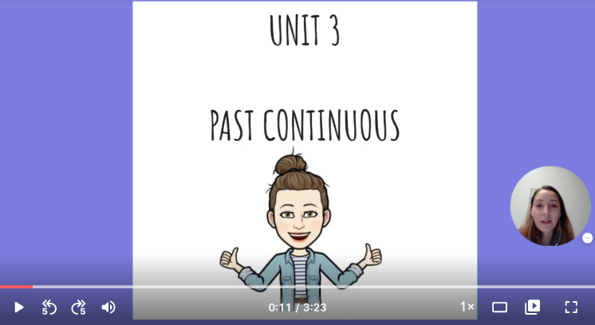

NOW GO ONLINE
CTRL+CLICK AND WORK ONLINE:
https://forms.gle/6njiaGw69Z1u3vWLA

PLEASE PRESS “SUBMIT/SEND” AT THE END OF YOUR ONLINE WORK
POR FAVOR PRESIONAR “ENVIAR” AL FINAL DEL TRABAJO EN LINEA

