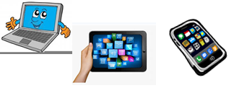
Name:…
Surname: …
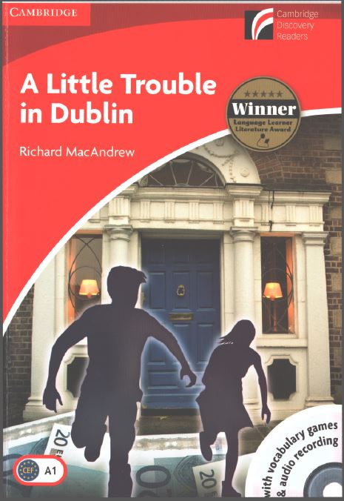
Home Schooling 34
Today we will work on chapters 7&8 of our reader
“A Little Trouble in Dublin”

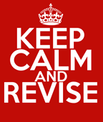

Answer these questions.
- Where are Andy and Mary at the beginning of chapter 6?
…

- Where are the twins at the end of that chapter?
…

- What are the two police officers going to do at the end of chapter 6?
…

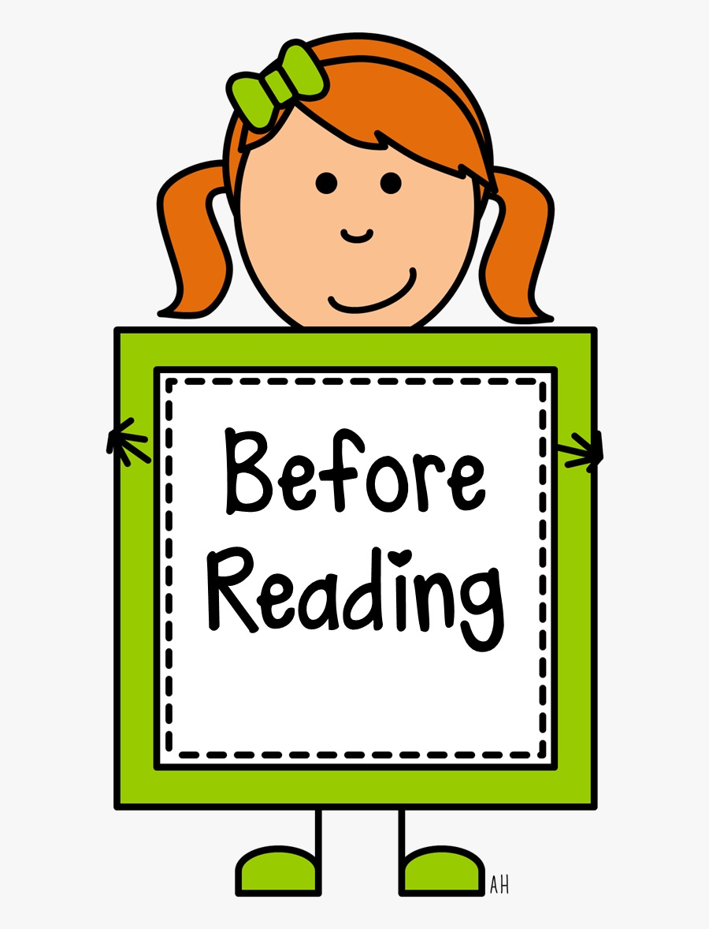

What do you think happens in the final two chapters?
Write Yes or No.

- Miss O’Brien comes to the police station.
…

- Andy and Mary do not see the men again.
…

- Andy and Mary help the police.
…

Now, listen/read chapters 7 and 8.
PDF file: https://bit.ly/3czAvQ0
Audio file Chapter 7: https://bit.ly/3dZv8JP
Audio file Chapter 8: https://bit.ly/2ZrunnO

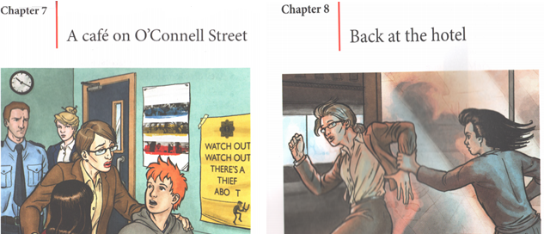
NOW GO ONLINE

CTRL+CLICK AND WORK ONLINE:
https://forms.gle/1SpbozTtxj7h2DQb7
PLEASE PRESS “SUBMIT/SEND” AT THE END OF YOUR ONLINE WORK
POR FAVOR PRESIONAR “ENVIAR” AL FINAL DEL TRABAJO EN LINEA

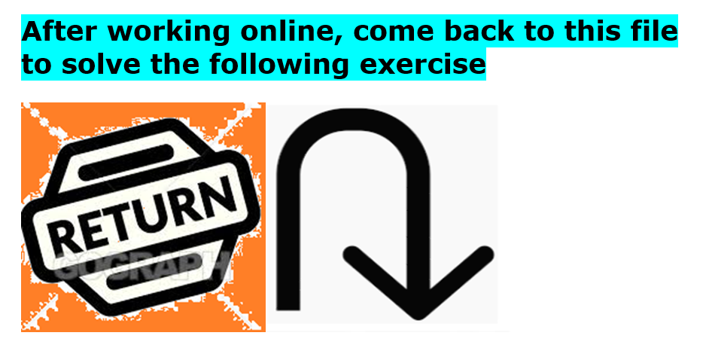

Complete this sentence with the thing you liked the most of our reader.

The thing I liked the best about “A LITTLE TROUBLE IN DUBLIN” was …
Let’s Create a scrapbook! We’ll share it at our first ZOOM class after the winter holidays
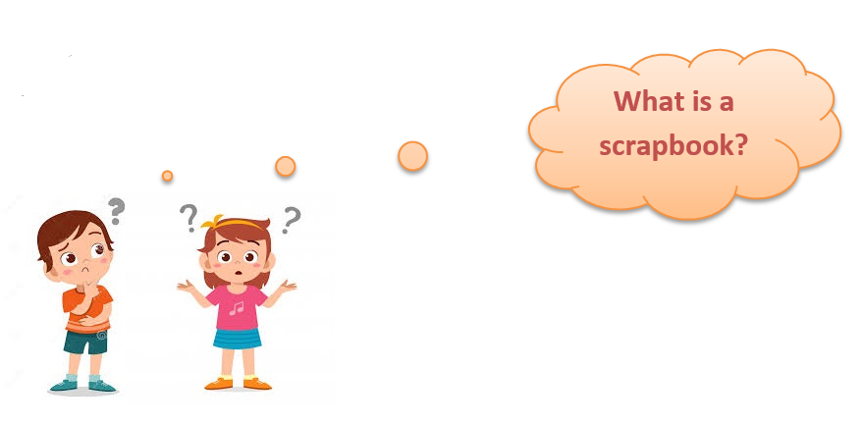
A scrapbook is a book or album with empty pages on which you can stick things such as pictures or newspaper articles or other things you want to keep.
Here, there is an example of a scrapbook about the book “The Witches” by Roald Dahl.
You may use it as a model. Your scrapbook doesn’t have to be identical.

Be creative!
You can include pictures, drawings, information about the characters, the author of the book, etc.
You can also include your feelings! (How did you feel while reading the book? Did you like it?)
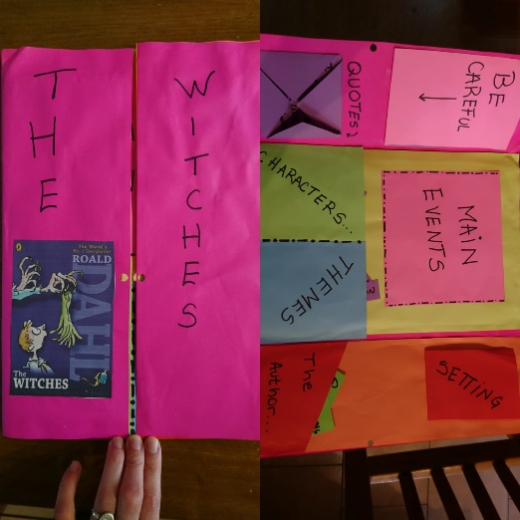

This is the cover and the inside.

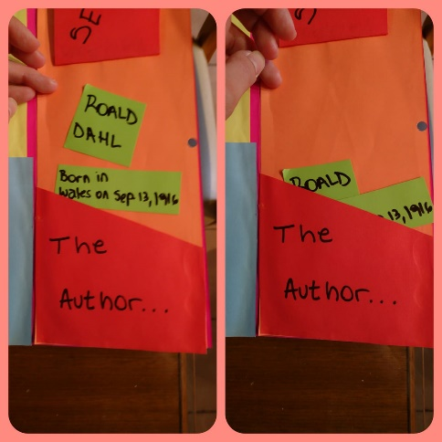

Here are some facts about the author!

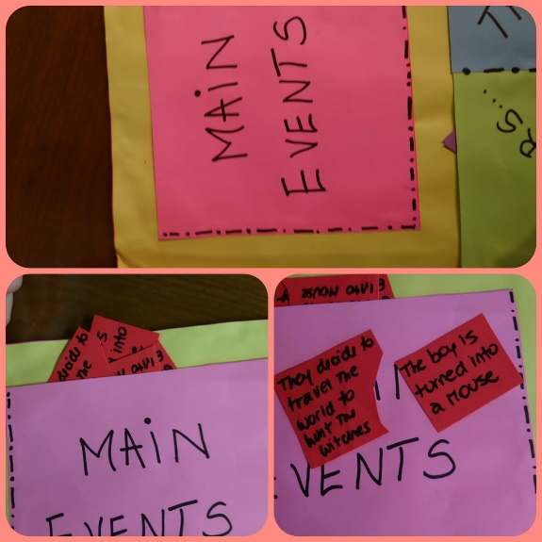

In here, you can write about the most important events of the story. You don’t need to write everything that happened, but just the most important events.

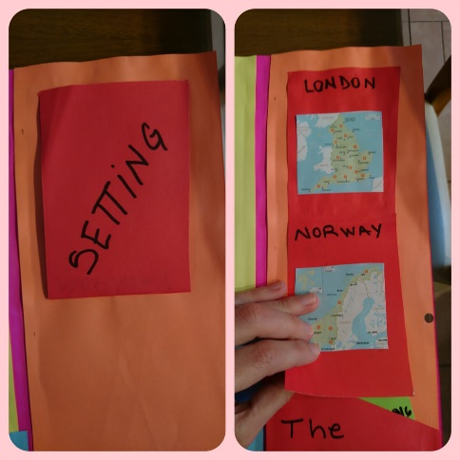

Remember that the setting is the time and place where the story happens.
In the setting section, you can include Google Maps pictures.

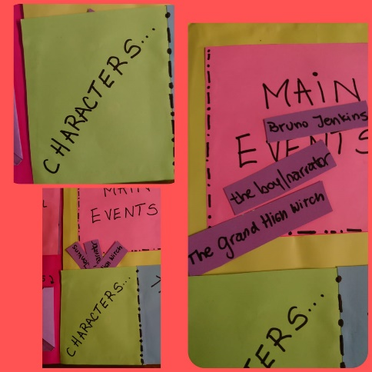
You can also include a characters section.
In there, you may write their names, include drawings etc.

