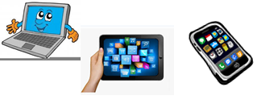
Name:…
Surname: …
Home Schooling 35
Hello again! Today we keep on working on UNIT 3 of Superminds!
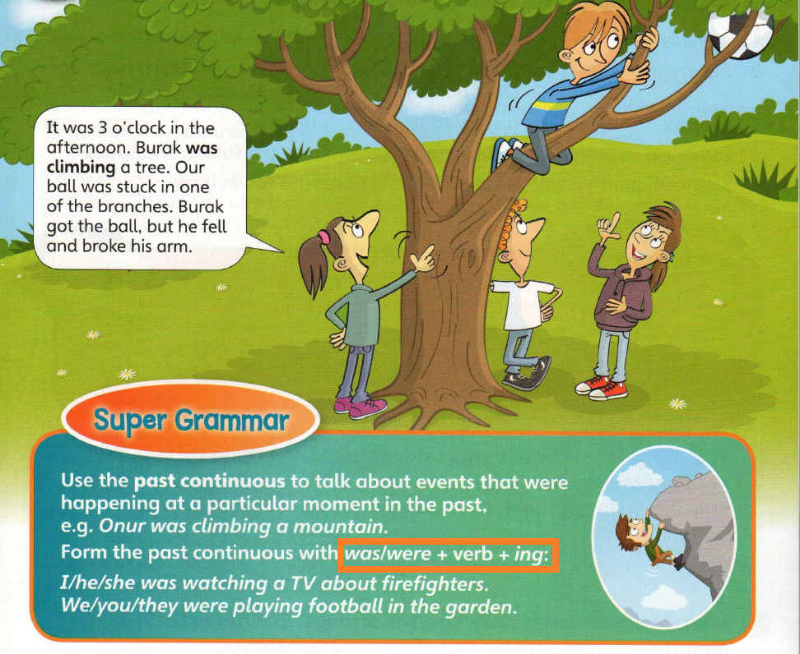
- Read and revise the use of PAST CONTINUOUS!

NOW GO ONLINE

CTRL + CLICK AND WORK ONLINE:
https://forms.gle/HMW1wFGs8WiD54qTA

PLEASE PRESS “SUBMIT/SEND” AT THE END OF YOUR ONLINE WORK
POR FAVOR PRESIONAR “ENVIAR” AL FINAL DEL TRABAJO EN LINEA

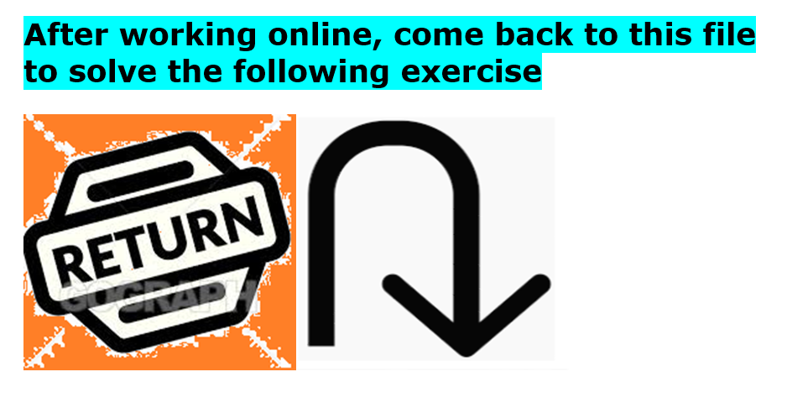

- Describe the picture. Use the words from the box.

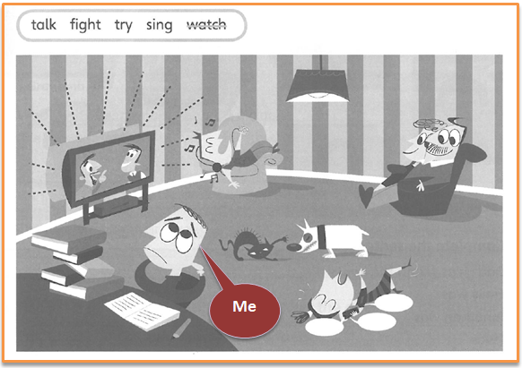

Yesterday at 8 o´clock,

- Mum and Dad were watching TV.
- My brother …
- My sister …
- The dog and the cat …
- And I …

- Complete the sentences so they are true for you.
- On Saturday morning I …
- On Saturday afternoon my parents …
- On Sunday morning I …
- On Sunday afternoon I …

This is the end of your file. Check you have solved all the activities, save your work and send it to your teacher via email:
4th Girls and Boys: msgabygar@gmail.com

