Name:…
Surname: …
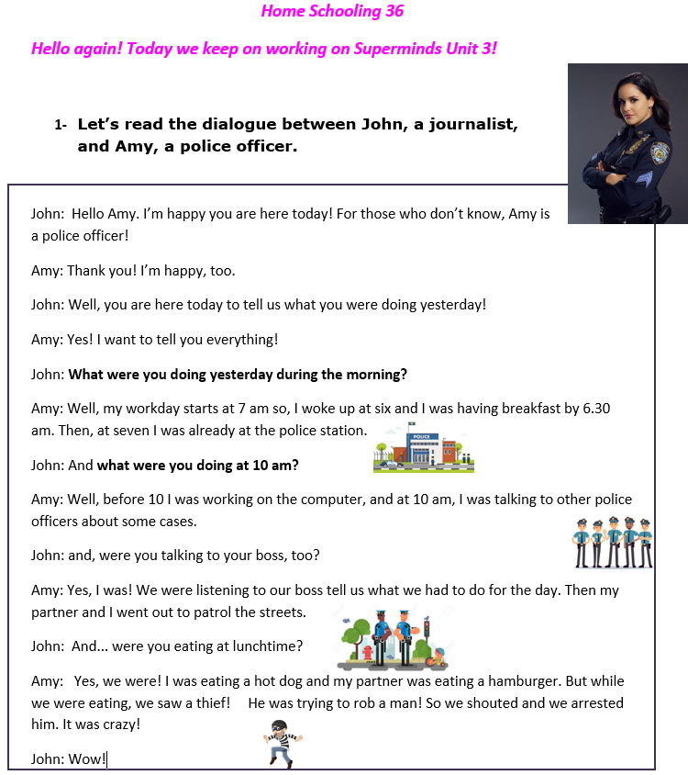
2-True or false?
https://www.educandy.com/site/resource.php?activity-code=2b20c
Have a look at these questions!
What were you doing yesterday during the morning?
What were you doing at 10 am?
Do these questions follow the normal sentence order? No, they don’t! They have a different order
Remember that a normal sentence order is:
SUBJECT + WAS/WERE + VERB-ING (ACTION)+ …
e.g.: I was having breakfast.

So, these sentences don’t follow this order because they are QUESTIONS
HOW DO WE MAKE QUESTIONS THEN?
LET’S REMEMBER THE HAMBURGER!
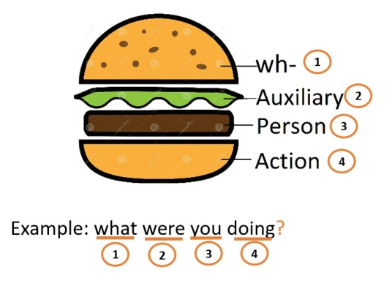

John: What were you doing at 10 am?
Amy: At 10 am, I was talking to other police officers about some cases.
You need to answer these questions with what you were doing!
Ex. What were you doing before the zoom meeting?
I was eating lunch.
3-Let’s practice!
https://www.liveworksheets.com/ar928197ny
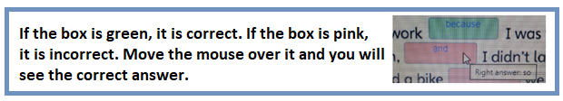

- Play this game!
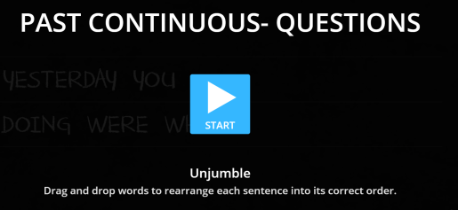
https://wordwall.net/play/3270/596/617

NOW GO ONLINE

CTRL+CLICK TO GO ONLINE
https://forms.gle/ADLEEifjUT44oUD76
PLEASE PRESS “SUBMIT/SEND” AT THE END OF YOUR ONLINE WORK
POR FAVOR PRESIONAR “ENVIAR” AL FINAL DEL TRABAJO EN LINEA

