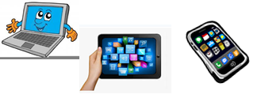
Name:…
Surname: …
Home Schooling 37
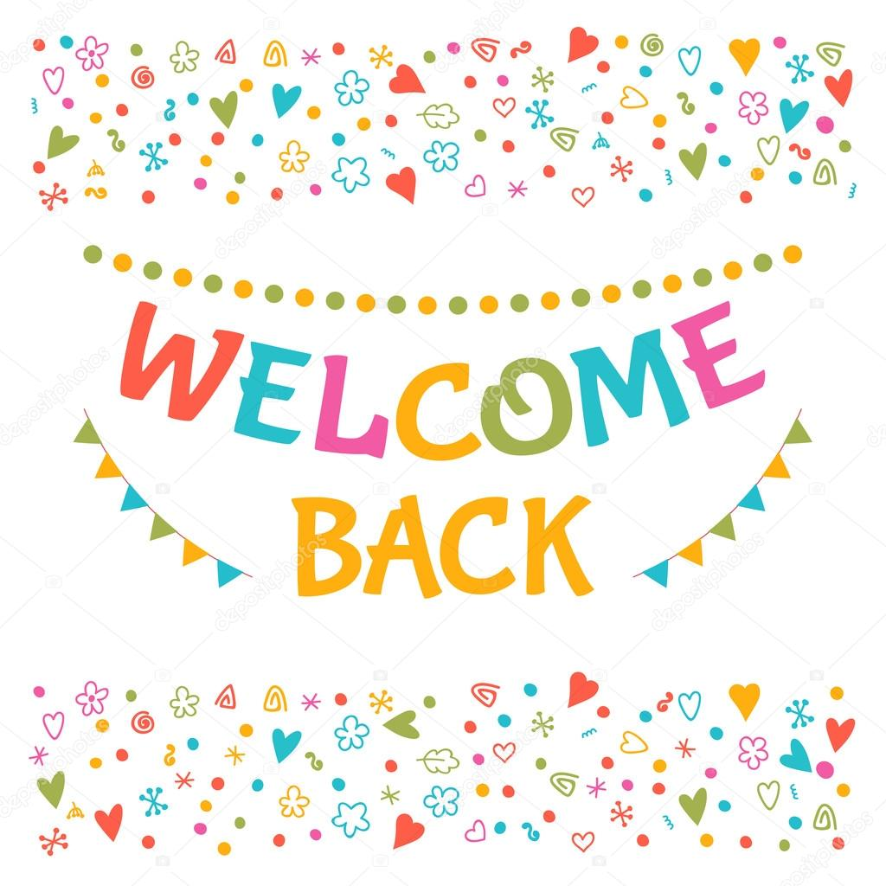
WE HOPE YOU HAD A NICE WINTER BREAK!

NOW GO ONLINE

CTRL + CLICK AND WORK ONLINE:
https://forms.gle/89G6uyxzPeuJscmS9
PLEASE PRESS “SUBMIT/SEND” AT THE END OF YOUR ONLINE WORK
POR FAVOR PRESIONAR “ENVIAR” AL FINAL DEL TRABAJO EN LINEA

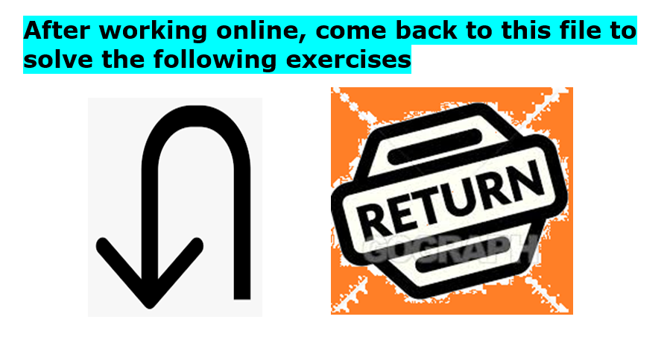

LET’S REVISE HOW TO MAKE QUESTIONS !

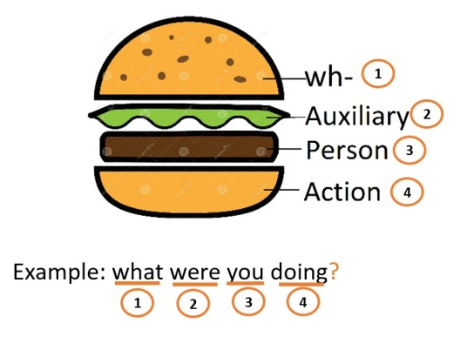
REMEMBER THE SANDWICH! QUESTIONS HAVE A DIFFERENT ORDER:

WH - WORD | AUXILIARY | SUBJECT | ACTION  VERB + -ING | ... ?

WHAT WERE YOU DOING AT 9 a.m. YESTERDAY MORNING?

I WAS LISTENING TO MUSIC AND HAVING BREAKFAST

- Read the answers and make questions! Pay attention to the answer to know
what to ask!

e.g. QUESTION: What was Tilly doing on December 26th?
ANSWER: Tilly was on holiday in Thailand enjoying the sea and the sun.

Question: ...
Answer: At 8 o’clock, Tilly was in the sea playing with a ball.

Question: ...
Answer: Some people were snorkelling and swimming.

Question: ...
Answer: Two boys were trying to catch a fish.

- Read this postcard Tilly sent to her friend Rachel on December 24th

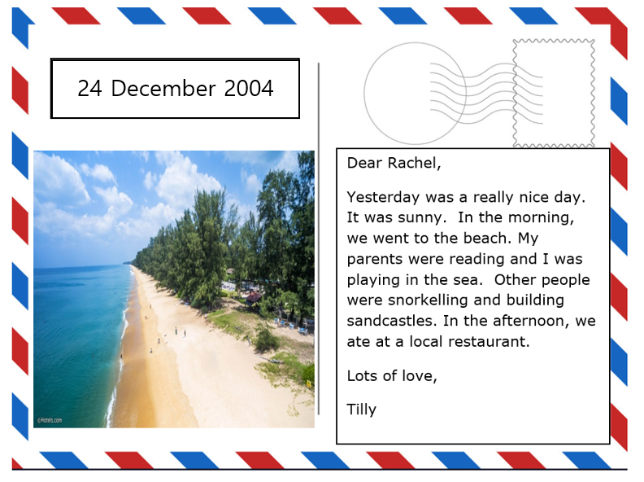

Now, it’s your turn! Imagine you are Tilly. Write another postcard to Rachel telling her what happened on December 26th. Write 40-50 words.
Use this information:
- where she is now (Dec 27th)
- what happened yesterday
- what she was doing when the Tsunami started
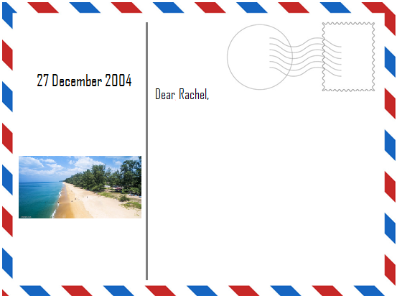
- what she is going to do now.
…

This is the end of your file. Check you have solved all the activities, save your work and send it to your teacher via email:
4th Girls and Boys: msgabygar@gmail.com

