Name:…
Surname: …
Home Schooling 38
Hello again! Today we keep on working on UNIT 3 of Superminds!

- Play the game to revise EMERGENCY VOCABULARY!
CLICK HERE: https://www.educandy.com/site/html5/bin/main.php?activity=multiple_pairs&quizid=183076
NOW GO ONLINE
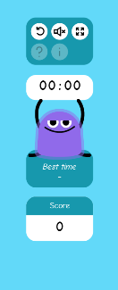

CTRL + CLICK and work online:
https://forms.gle/WqAHyJgKAGgLmcuf6
PLEASE PRESS “SUBMIT/SEND” AT THE END OF YOUR ONLINE WORK
POR FAVOR PRESIONAR “ENVIAR” AL FINAL DEL TRABAJO EN LINEA

