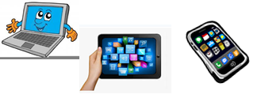
Name: …
Surname: …
Home Schooling 39
Hello again! Today we keep on working on UNIT 3 of Superminds!

- Let’s revise the words we learnt so far!
Follow the link and put the words in the correct category.
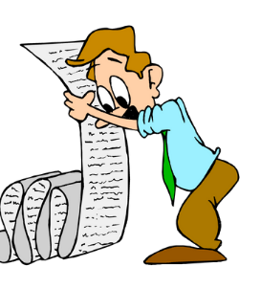
CLICK HERE: https://learningapps.org/watch?v=p12pb8yd220
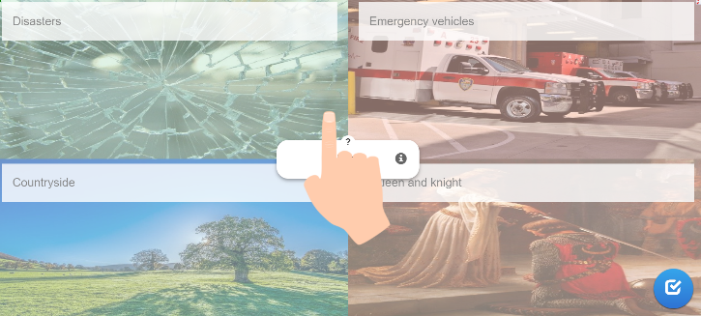

- Follow the link and put the dialogue in order.
CLICK HERE: https://www.liveworksheets.com/lr1007003uj

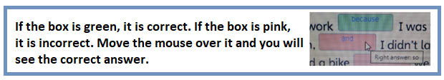

- Open your Superminds on page 45.
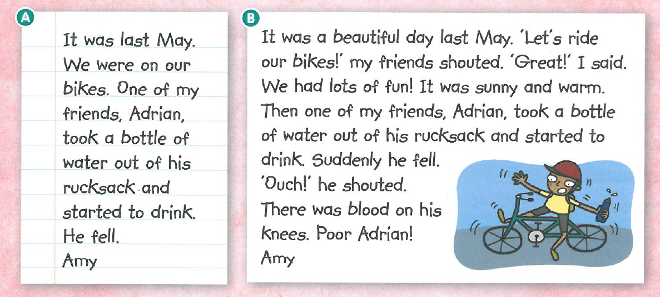
Read Amy’s stories about the same accident.

Which text is better? …

- Now, write a story about an accident. It can be a true story or you can imagine it.
(40 - 50 words)
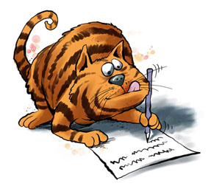
Include:
- When did it happen?
- Who were with you?
- What were you doing?
- What happened?
- Who was hurt?

…

Optional activity
- Draw a picture of the accident in your copybook!

This is the end of your file. Check you have solved all the activities, save your work and send it to your teacher via email:
4th Boys: msmicaelaferrero@gmail.com
4th Girls: msgabygar@gmail.com

