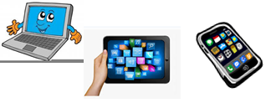
Name: …
Surname: …
Home Schooling 40
Hello! Today we finish UNIT 3 of Superminds!

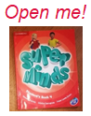
- Let’s revise what we learnt in unit 3! Follow the link and work on page 121 of Superminds.
CLICK HERE: https://www.liveworksheets.com/gs1014970se
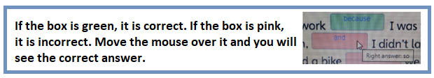

NOW GO ONLINE

CTRL+CLICK AND WORK ONLINE:
https://forms.gle/NTLyswrVoKbTXxn99
PLEASE PRESS “SUBMIT/SEND” AT THE END OF YOUR ONLINE WORK
POR FAVOR PRESIONAR “ENVIAR” AL FINAL DEL TRABAJO EN LINEA

