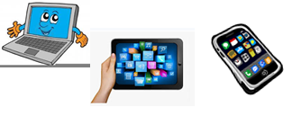
Name :…
Surname: …
Home Schooling 41
Hi! Today we start working on unit 4 of Superminds!

NOW GO ONLINE

CTRL + CLICK and work online:
https://forms.gle/LaDrnDZzMwnW5NMN9
PLEASE PRESS “SUBMIT/SEND” AT THE END OF YOUR ONLINE WORK
POR FAVOR PRESIONAR “ENVIAR” AL FINAL DEL TRABAJO EN LINEA

