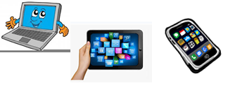
Name:…
Surname: …
Home Schooling 42
Hello! Today we work on unit 4 of Superminds.

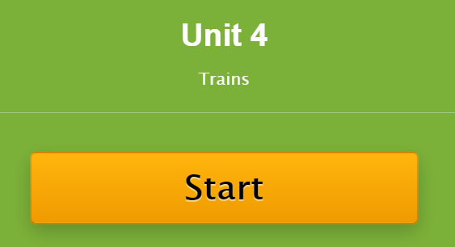
- Let’s revise! Solve this crossword!
https://es.educaplay.com/recursos-educativos/6552132-unit_4.html

- Let’s go online!

https://www.liveworksheets.com/cj1030927ef
WHEN YOU FINISH CLICK ON
“FINISH” AND THEN ON “CHECK
MY ANSWERS”

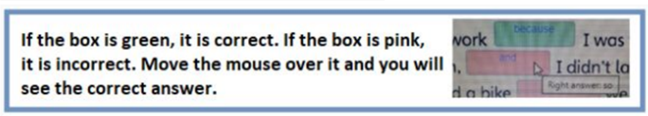

- Choose five words from the vocabulary learnt and write five sentences.

- …
- …
- …
- …
- …

This is the end of your file. Check you have solved all the activities, save your work and send it to your teacher via email:
4th Boys: msmicaelaferrero@gmail.com
4th Girls: msgabygar@gmail.com

