Name: …
Surname: …
- Follow the link and work online.
CLICK HERE: https://www.liveworksheets.com/pe1061149le

- Watch Miss Gaby’s video and learn PREPOSITIONS OF TIME!
CLICK HERE:https://www.loom.com/share/d8adb9f8c0404d6a81a8ca490ad6c13f

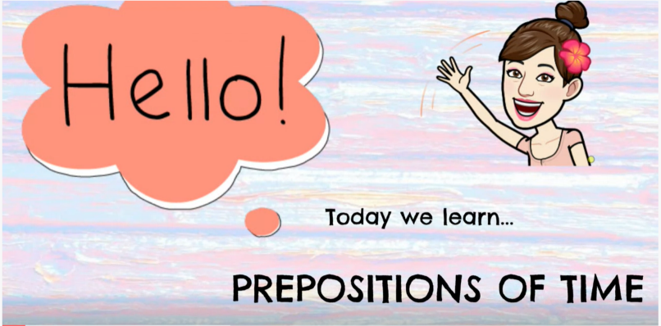

NOW GO ONLINE

- CTRL + CLICK and work online.
https://forms.gle/PS9nCxctM59FU3xc9
PLEASE PRESS “SUBMIT/SEND” AT THE END OF YOUR ONLINE WORK
POR FAVOR PRESIONAR “ENVIAR” AL FINAL DEL TRABAJO EN LINEA

