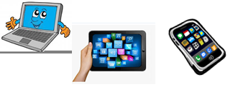
Name:…
Surname: …
Home Schooling 44
Hi! Today we continue working on unit 4 of Superminds!
NOW GO ONLINE

- CTRL + CLICK AND WORK ONLINE.

https://forms.gle/9qM4vkiRLrh99wfD8

PLEASE PRESS “SUBMIT/SEND” AT THE END OF YOUR ONLINE WORK
POR FAVOR PRESIONAR “ENVIAR” AL FINAL DEL TRABAJO EN LINEA

