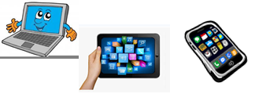
Name: …
Surname: …
Home Schooling 45
Today we continue working on unit 4 of Superminds!

- Let’s revise prepositions of time. Solve the puzzle and have fun!
CTRL + CLICK here: https://www.liveworksheets.com/kk193663si
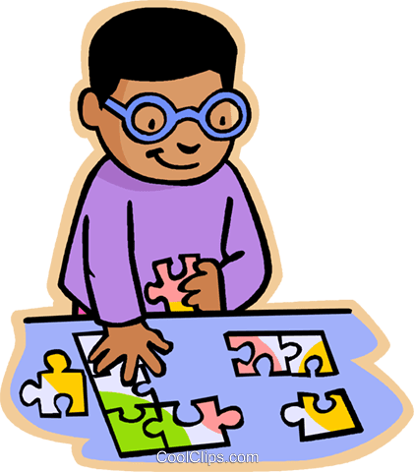
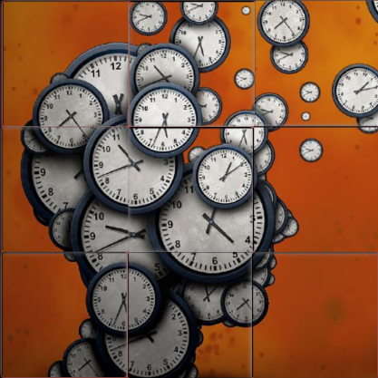

NOW GO ONLINE

CTRL + CLICK and work online:
https://forms.gle/mvNKzZW9ddURg9gS9
PLEASE PRESS “SUBMIT/SEND” AT THE END OF YOUR ONLINE WORK
POR FAVOR PRESIONAR “ENVIAR” AL FINAL DEL TRABAJO EN LINEA

