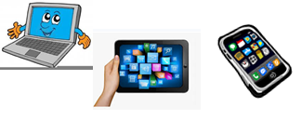
Name :…
Surname: …
Home Schooling 46
Today we continue working on unit 4 of Superminds!

- Go online and revise vocabulary learnt in unit 4
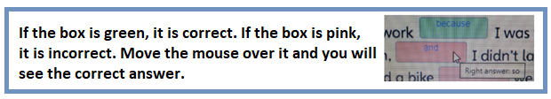
CTRL+CLICK here: https://www.liveworksheets.com/os1081095qd

NOW GO ONLINE

CTRL + CLICK and work online:
https://forms.gle/ZPr82Qs5wL6frLKk9
PLEASE PRESS “SUBMIT/SEND” AT THE END OF YOUR ONLINE WORK
POR FAVOR PRESIONAR “ENVIAR” AL FINAL DEL TRABAJO EN LINEA

