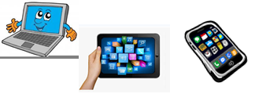
Name:…
Surname: …
Home Schooling 47
Hello! Let’s continue working on unit 4 of Superminds!
GO ONLINE

CTRL + CLICK and work online:
https://forms.gle/RHdvVY9m5nyUYN8W9

PLEASE PRESS “SUBMIT/SEND” AT THE END OF YOUR ONLINE WORK
POR FAVOR PRESIONAR “ENVIAR” AL FINAL DEL TRABAJO EN LINEA

