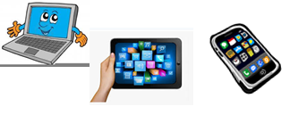
Name : …
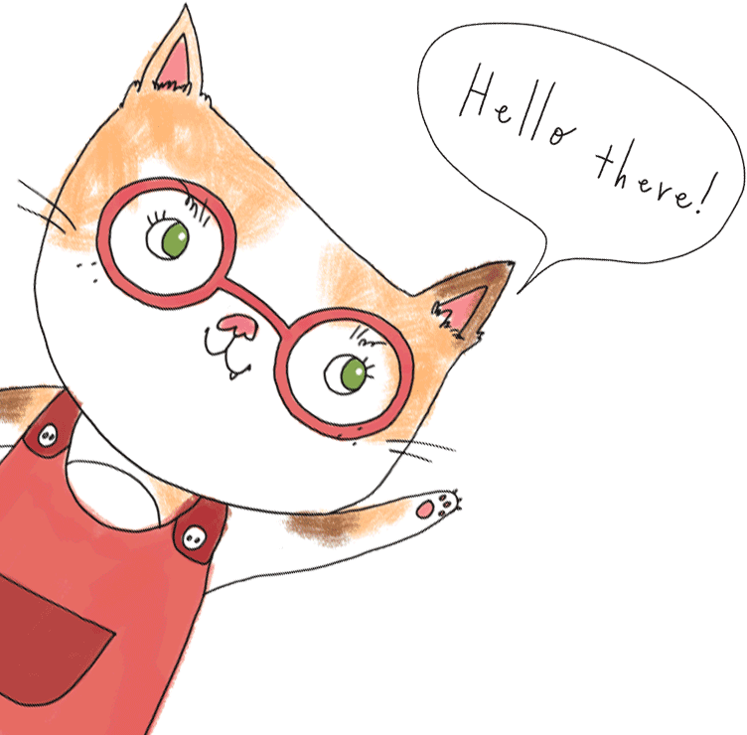
Surname: …
Home Schooling 49
Today we finish working on unit 4 of Superminds!

GO ONLINE

CTRL + CLICK and work online:
https://forms.gle/ny22FJQb4BWkDVS79
PLEASE PRESS “SUBMIT/SEND” AT THE END OF YOUR ONLINE WORK
POR FAVOR PRESIONAR “ENVIAR” AL FINAL DEL TRABAJO EN LINEA

