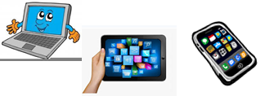
Name:…
Surname: …
Home Schooling 55
Hello! Today we work on unit 5 of Superminds!

GO ONLINE

CTRL + CLICK and work online:
https://forms.gle/csKupzKKhzyAKDq8A
PLEASE PRESS “SUBMIT/SEND” AT THE END OF YOUR ONLINE WORK
POR FAVOR PRESIONAR “ENVIAR” AL FINAL DEL TRABAJO EN LINEA

