Name: …
Surname: …
Home Schooling 69
Hello!
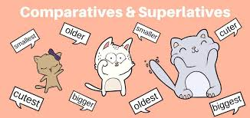
GO ONLINE

CTRL + CLICK and work online:
https://forms.gle/obKCad3MmeH2sFCa7
PLEASE PRESS “SUBMIT/SEND” AT THE END OF YOUR ONLINE WORK
POR FAVOR PRESIONAR “ENVIAR” AL FINAL DEL TRABAJO EN LINEA

