***Name:… Surname: …***

***Home Schooling 23 ***

**Practice Time!**

smiley smallPress ctrl and click to listen to the audio file:

1. **Listen to these kids talking about their lives.**

**Complete the sentences below with the activity each one did.**

**Choose from the activities provided. Remember to put the verbs in the Past Simple!** [**https://bit.ly/2BY7hNE**](https://bit.ly/2BY7hNE)

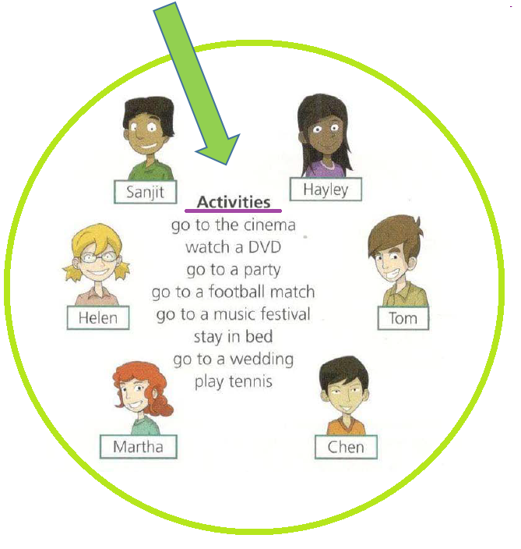

Dialogue 1

Snijt **went to a music festival.**

Helen **…**

Dialogue 2

Martha **…**

Hayley **…**

Dialogue 3

Tom **…**

Chen **…**

1. **YOUR TURN! Answer these questions about you:**



How was your weekend? **…**

What did you do? **…**

Did you have fun? **…**



1. **Do you remember Carl from the online activities last week?**

**He lived in New Zealand but now he lives in London. Carl loved his country and did not want to go to London at first.**

**Look at the things he does differently now. Can you compare them? Complete with the verbs in the past.**

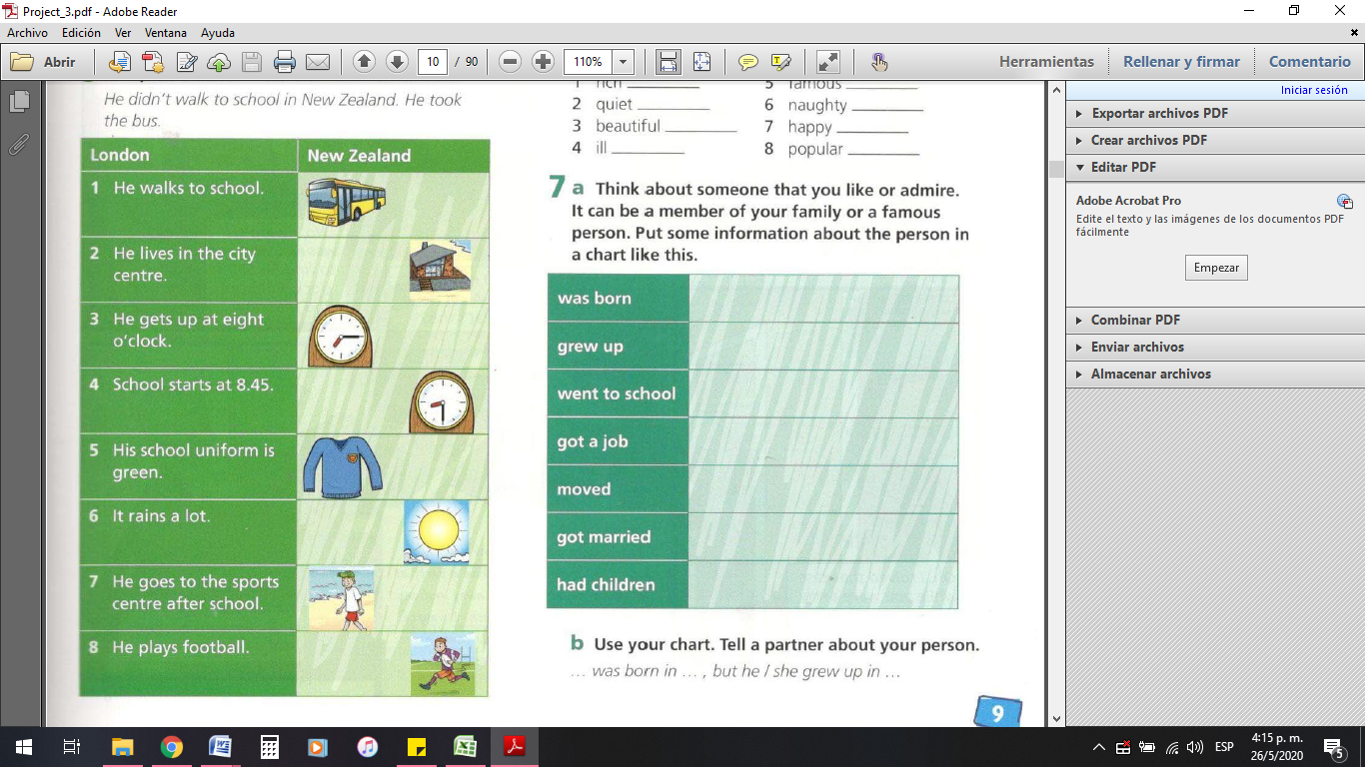

**Example:** 1- In London he walks to school. In New Zealand he went (go) to school by bus.

2- In London he lives in the city centre. In New Zealand he **…** (live) in the countryside.

3- In London he gets up at eight o'clock. In New Zealand he **…** (get) up at 7:15.

4- In London he starts school at 8:45. In New Zealand he **…** (start) school at 8:30.

5- In London his school uniform is green. In New Zealand it **…** (is) blue.

6- In London it rains a lot. In New Zealand it **…** (be) sunny.

7- In London he goes to the sports centre after school. In New Zealand he **…** (walk) on the beach.

8. In London he plays football. In New Zealand he **…** (play) rugby.

**4) GAME TIME: Go to these sites to practise:**

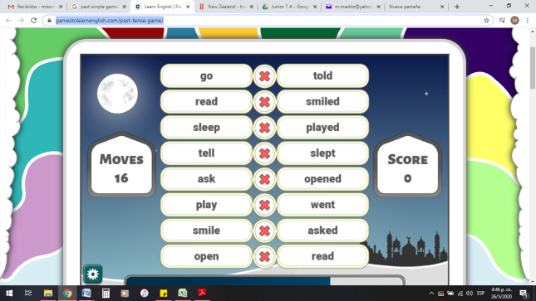

<https://www.gamestolearnenglish.com/past-tense-game/>

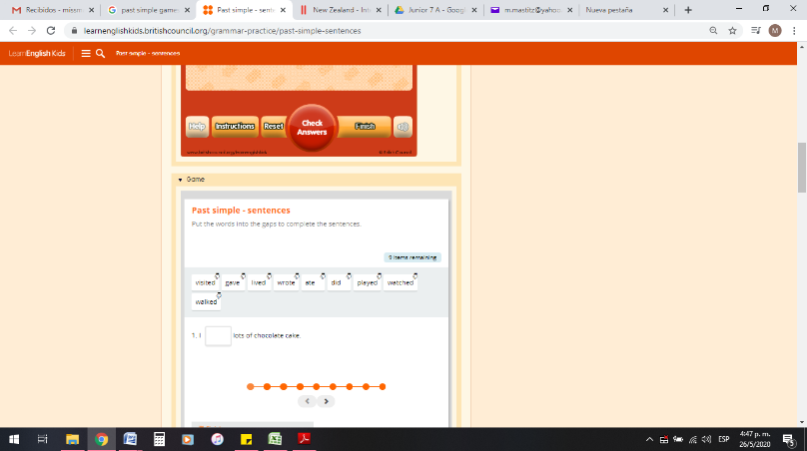

<https://learnenglishkids.britishcouncil.org/grammar-practice/past-simple-sentences>

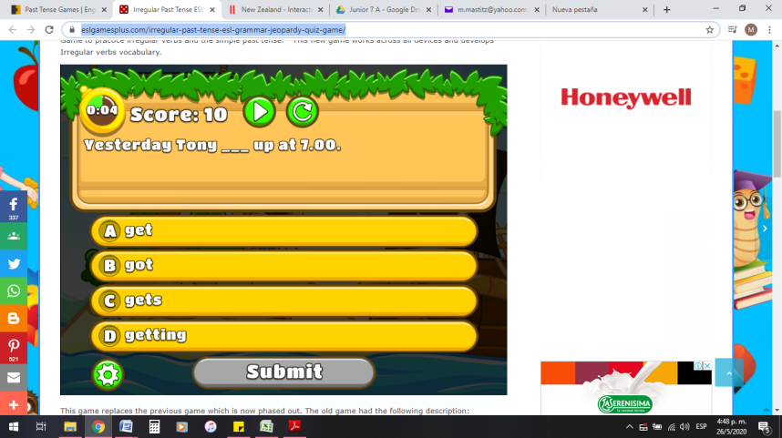

<https://www.eslgamesplus.com/irregular-past-tense-esl-grammar-jeopardy-quiz-game/>

1. **Go online to practise a bit more!**

**To help you, use the Irregular Verb list click here:** [**https://bit.ly/3huxAvd**](https://bit.ly/3huxAvd) **and the rules click here** [**https://bit.ly/2Yw0rWZ**](https://bit.ly/2Yw0rWZ)

**Remember to press FINISH and EMAIL MY ANSWERS TO MY TEACHER to send the results. Complete with your name and form.**

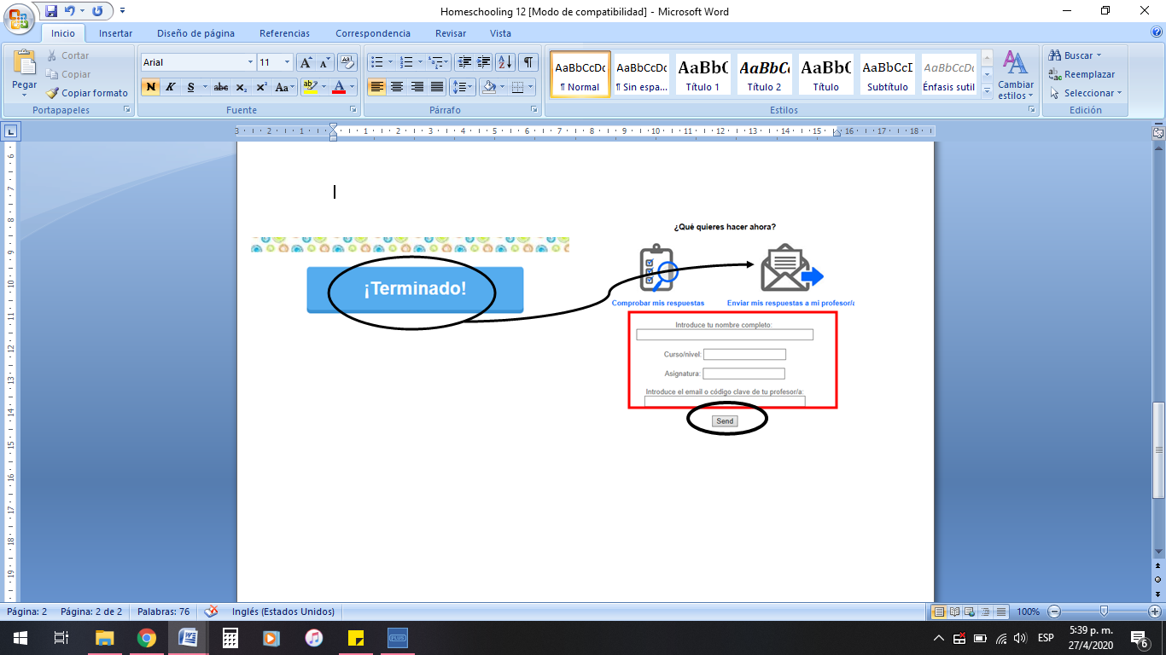

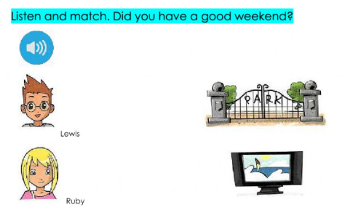

<https://www.liveworksheets.com/worksheets/en/English_as_a_Second_Language_(ESL)/Past_simple/Did_you_have_a_good_weekend$_pq93528oz>

**NOW WE**

**GO ONLINE AGAIN**

**CTRL+CLICK AND WORK ONLINE:**

[**https://forms.gle/ih73SGGbGJBnQ37L8**](https://forms.gle/ih73SGGbGJBnQ37L8)

|  |
| --- |
| **PLEASE PRESS “SUBMIT/SEND” AT THE END OF YOUR ONLINE WORK.**  **POR FAVOR PRESIONAR “ENVIAR” AL FINAL DEL TRABAJO EN LINEA.** |

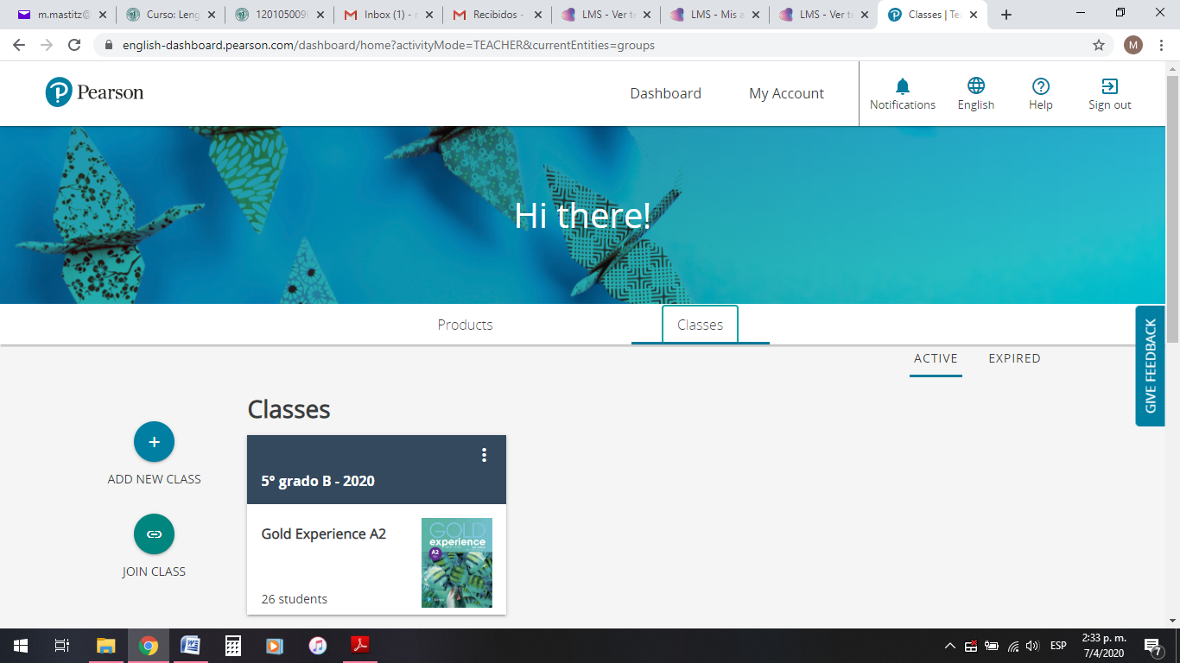**PEARSON PORTAL**

|  |
| --- |
| **Please access your virtual class at Pearson and solve the assigned activities** |



This is the end of your file. Check you have solved all the activities, save your work and send it to your teacher via email:

5th Girls: [msmacarenam@gmail.com](mailto:msmacarenam@gmail.com)

5th Boys: [msrominap@gmail.com](mailto:msrominap@gmail.com)