Name: … Surname: …

NOW GO ONLINE

CTRL+CLICK AND WORK ONLINE:
https://forms.gle/PBQgDRPeg1x7Vip1A
PLEASE PRESS “SUBMIT/SEND” AT THE END OF YOUR ONLINE WORK.
POR FAVOR PRESIONAR “ENVIAR” AL FINAL DEL TRABAJO EN LINEA.
When is shopping interesting for you?
...
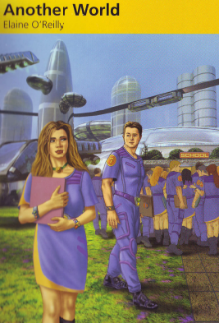
ANOTHER WORLD (Reader book)

CTRL+CLICK TO READ AND LISTEN TO CHAPTER 8 OF THE STORY:
https://bit.ly/2E1hKsU
Then, solve the activities here.
Finish Eve's notes for her boss in the Office of The People's Happiness:
NAME OF TEAM WORKER: EVOO7
NAME OF STUDENT: BZXY741
SCHOOL NOTES: BZXY741 is intelligent, a good ... and very good at sport. No problems.
FIRST MEETING: On the ..., on the way to school.
SECOND MEETING: At the House of ...
PROCEDURE: I told him about the ... world. He didn't ... me, of course. I then took him to the city of ... in a box in the ... and showed him the people and the ... . He was afraid.
REACTIONS TO PEOPLE: The waitress: Good. He was embarrassed and couldn't ... at her.
The beggar: Better. He was ... and we had to leave the ... .
My family: Very good. He was afraid and ... when he saw my mother and ... . He ... the idea of them.
IS THE A GOOD STUDENT FOR THE TEAM? SAY WHY.
...

PEARSON PORTAL
Please access your virtual class at Pearson and solve the assigned activities

This is the end of your file. Check you have solved all the activities, save your work and send it to your teacher via email:
5th Girls: msmacarenam@gmail.com
5th Boys: msrominap@gmail.com

