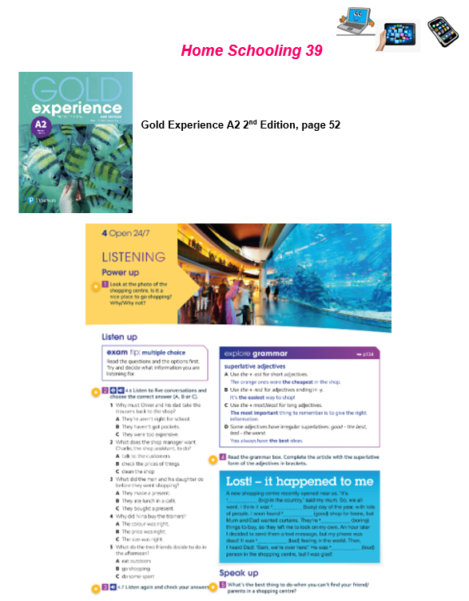
Name: … Surname: …
1- Look at the picture of the shopping centre. Is it a nice place to go shopping? Why/why not?
...

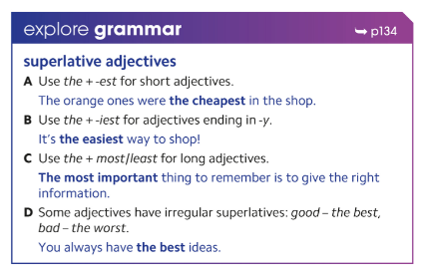
2- Do you remember superlative adjectives? Here you've got the rules again.

Now, complete the article with the superlative of the adjectives in brackets:
Lost! – it happened to me
A new shopping centre recently opened near us. ‘It’s 1… (big) in the country,’ said my mum. So, we all went. I think it was 2… (busy) day of the year, with lots of people. I soon found 3… (good) shop for teens, but Mum and Dad wanted curtains. They’re 4… (boring) things to buy, so they left me to look on my own. An hour later I decided to send them a text message, but my phone was dead! It was 5… (bad) feeling in the world. Then, I heard Dad: ‘Sam, we’re over here!’ He was 6… (loud) person in the shopping centre, but I was glad!

3- What is the best thing to do when you can't find your friend/parents in a shopping centre?
...
NOW GO ONLINE

CTRL+CLICK AND WORK ONLINE:
https://forms.gle/RDyqvtEWyKedwVBdA
PLEASE PRESS “SUBMIT/SEND” AT THE END OF YOUR ONLINE WORK.
POR FAVOR PRESIONAR “ENVIAR” AL FINAL DEL TRABAJO EN LINEA.

PEARSON PORTAL
Please access your virtual class at Pearson and solve the assigned activities

This is the end of your file. Check you have solved all the activities, save your work and send it to your teacher via email:
5th Girls: msmacarenam@gmail.com
5th Boys: msrominap@gmail.com

