Name: … Surname: …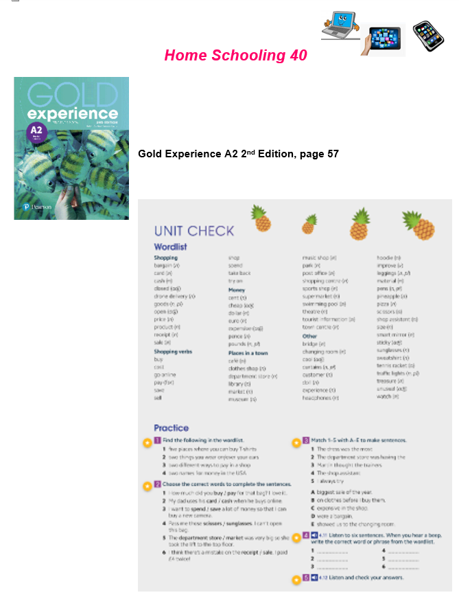

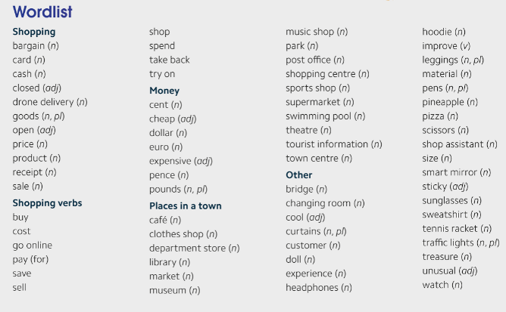
1- Look at the list of words and find:

- five places where you can buy T-shirts:
...
- two things you wear on/over your ears:
...
- two different ways to pay in a shop:
...
- two names for money in the USA:
...

2- Listen to six sentences and write the correct missing word or phrase from the wordlist:

https://bit.ly/3lmAfIL

1- The shop assistant gave her the jeans in a different ... , but they were still too big.
2- I only paid thirty pounds for my new watch. It was a ...
3- Look, you can ... the dress in the changing rooms over there.
4- Oh no, we can't go in the shop now. It's ... until Monday.
5- Excuse me, can you tell me the ... of this book? I can't find it anywhere.
6- Jack wants to ... his old bike. How much do you think he can get for it?

NOW GO ONLINE

CTRL+CLICK AND WORK ONLINE:

https://forms.gle/GMx5mW2A4rPJZoAR6

PLEASE PRESS “SUBMIT/SEND” AT THE END OF YOUR ONLINE WORK.
POR FAVOR PRESIONAR “ENVIAR” AL FINAL DEL TRABAJO EN LINEA.

PEARSON PORTAL
Please access your virtual class at Pearson and solve the assigned activities

This is the end of your file. Check you have solved all the activities, save your work and send it to your teacher via email:
5th Girls: msmacarenam@gmail.com
5th Boys: msrominap@gmail.com

