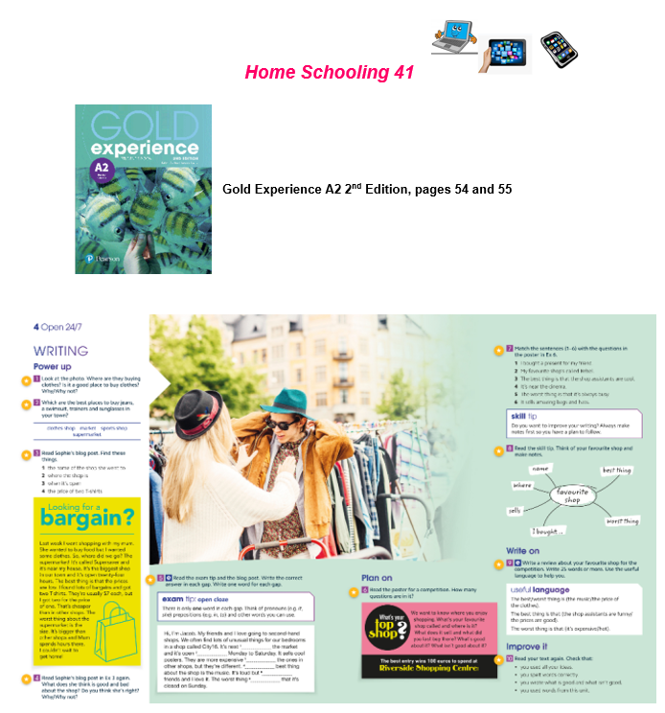
Name: … Surname: …

1- Look at the picture. Why are they buying clothes? Is it a good place to buy clothes? Why/why not?
…

2- Look at the list of shops. Which are the best places to buy jeans, a swimsuit, trainers and sunglasses?

…
3- Read Sophie's blog post. Find these things:  a- the name of the shop she went to: ...  b- where the shop is: ...  c- when it's open: ...  d- the price of two T-shirts: ... | 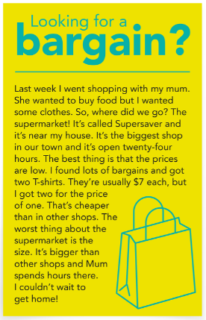

4- Read the post again. What does Sophie think is good and bad about the shop? Do you think she is right? Why/why not?
...

5- Read the exam tip and the blog post. Write the correct answer in each gap. Write only ONE word for each gap:

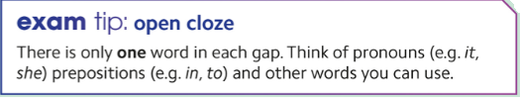

Hi, I’m Jacob. My friends and I love going to second-hand shops. We often find lots of unusual things for our bedrooms in a shop called City16. It’s next 1… the market and it’s open 2… Monday to Saturday. It sells cool posters. They are more expensive 3 … the ones in other shops, but they’re different. 4… best thing about the shop is the music. It’s loud but 5 … friends and I love it. The worst thing 6… that it’s closed on Sunday.

6- Write on! Read this poster for a competition. Think about your favourite shop and make notes using the mind map. Then, Write a review about that shop for the competition. Write 25 words or more. You can use the Useful Language box to help you:

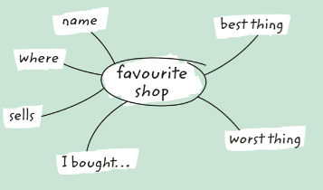
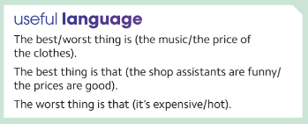

Your answer:
...

PEARSON PORTAL
Please access your virtual class at Pearson and solve the assigned activities

This is the end of your file. Check you have solved all the activities, save your work and send it to your teacher via email:
5th Girls: msmacarenam@gmail.com
5th Boysmsrominap@gmail.com

