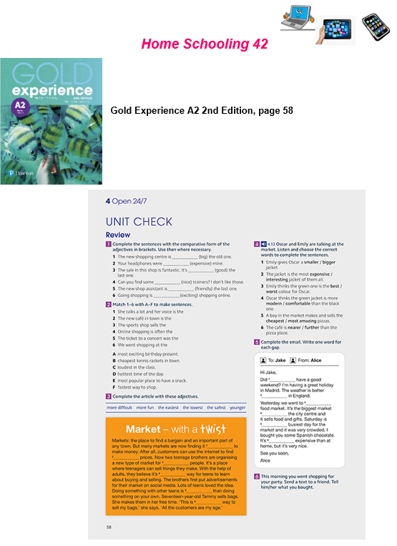
Name: … Surname: …
UNIT CHECK
1- Complete the sentences with the comparative form of the adjectives in brackets. Use THAN where necessary:
1. The new shopping centre in ... (big) the old one.
2. Your headphones were ... (expensive) mine.
3. The sale in this shop is fantastic. It's ... (good) the last one.
4. Can you find some ... (nice) trainers? I don't like those.
5- The new shop assistant is ... (friendly) the last one.
6- Going shopping is ... (exciting) shopping online.

2- Complete the email writing only ONE word for each gap:

Hi Jake,
Did 1 … have a good weekend? I’m having a great holiday in Madrid. The weather is better 2 … in England.
Yesterday we went to 3 … food market. It’s the biggest market 4 … the city centre and it sells food and gifts. Saturday is 5 … busiest day for the market and it was very crowded. I bought you some Spanish chocolate. It’s 6 … expensive than at home, but it’s very nice.
See you soon,
Alice

NOW GO ONLINE

CTRL+CLICK AND WORK ONLINE:
https://forms.gle/iJZb8bDMduYAiCPF7

PLEASE PRESS “SUBMIT/SEND” AT THE END OF YOUR ONLINE WORK.
POR FAVOR PRESIONAR “ENVIAR” AL FINAL DEL TRABAJO EN LINEA.

This is the end of your file. Check you have solved all the activities, save your work and send it to your teacher via email:
5th Girls: msmacarenam@gmail.com
5th Boys: msrominap@gmail.com

