Name: … Surname: …
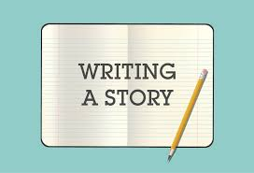
Home Schooling 10
WRITING A STORY:

1) Read a student’s story. Replace the words in brackets with these words in the box.
delicious disgusting furious
hilarious huge terrible
You can use a dictionary to check the meaning of the words above: www.dictionary.com
An evening to forget
We expected to have a great evening. We were on holiday. We decided to eat at a restaurant that described its food as (very nice) 1 … . It was as (very big) 2… but there weren’t many people there. We soon found out why; the waitress didn’t remember what we asked for and brought us the wrong food.
At first, we thought it was (very funny) 3 … but when she brought us the wrong things a second time, we stopped laughing. It was late, so we decided to eat the food. Unfortunately, it was not nice) 4… Then things got worse when she dropped a drink on my dad, and the drink wasn’t even for him! After so many mistakes, we were (very angry) 5… when we saw the bill. It was extremely expensive, and there was no discount!
We all agreed that going there was a (very bad) 6… decision!
2) Have any of these things happened to you when you were speaking in another language? Where were you when it happened? What were you doing?
- You forget a word.
- You go red.
- You panic and say nothing.
- You say the wrong word.

Choose a real or imaginary situation you would like to write about. You can choose one of the situations below: 1, 2 or 3.
When you write remember to include all this information.

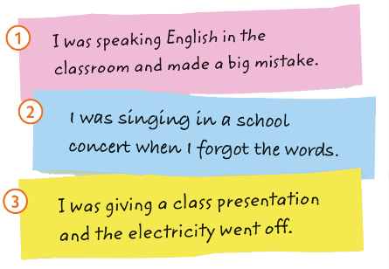
a) When did it happen? For example: At a school concert
b) Where did it happen? For example: On stage
c) Who was there? For example: Teachers and audience
d) What was the main action / situation / problem? For example: Forgot words to the song, froze on stage
e) What happened in the end? For example: Classmates helped to sing the song

- When we talk about the main events in a story, we use the past simple
- To say what we were doing at a certain time in the past we use the past continuous.
- Use a variety of adjectives and adverbs.
- Use strong adjectives to make our writing more interesting.

ADJECTIVES:
awful | brilliant | delicious | disgusting | fantastic
furious | hilarious | huge | terrible | wonderful

We can also use an adverb to make an adjective stronger.
really kind | very big | extremely dangerous

We don’t use very or extremely with strong adjectives. We use absolutely.
absolutely fantastic
absolutely brilliant
3) Now , write your story in about 100 words. Use your notes from Ex 2 to help you. Remember to use simple past and past continuous.
…

TIP!
After you wrote your story: Check:
- your language and spelling mistakes
- the number of words you have written
- the tenses of the verb.

This is the end of your file. Check you have solved all the activities, save your work and send it to your teacher via email:
Ezequiel: mrlavena7th@gmail.com
Gisela: msgisela7th@gmail.com
Florencia: msflorz7th@gmail.com
Camila: mscamila7th@gmail.com

