Name: …  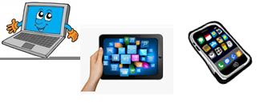 | Surname: …
Home Schooling 19

What can we do to help our planet?

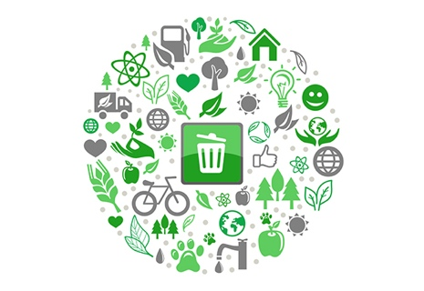
We can all do something to save our planet. In the next activities we are going to explore what people do, are doing and did to save it and what you can do to contribute. All our effort really matters!

Vocabulary

First, let’s have a look at some vocabulary we need, to start talking about the planet and what we can do to save it.
- Fill the chart up with the words below.
- Illustrate them with pictures or photos and/or example sentences. If you include sentences, you can use the Past and the Present Simple and the Present and Past Continuous. You can find some examples in the chart.
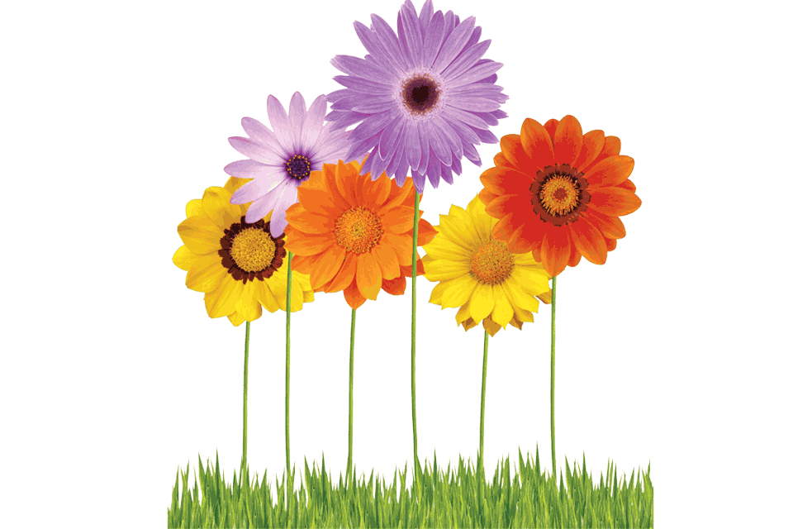
reusing – global warming – having short showers – air pollution – water pollution – using public transport – recyclables – to turn on/off a tap – recycling –
to separate rubbish – glass/plastic containers – biking or cycling to school –
turning off lights after you – organic waste – using LED or energy saving light bulbs – not using plastic bags –using cloth bags

Rubbish | Water | Climate change | Green habits
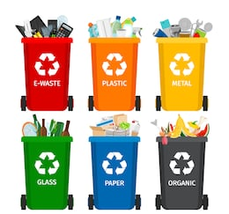  To separate rubbish  … | Having short showers  “I have short showers every day”.  … | Air pollution  … | Recycling  “My sister and I were recycling this morning”.  …
… | … | … | …
… | … | … | …
… | … | … | …

Listening

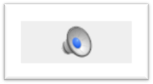
Click to listen:
https://bit.ly/35pOPbi

Listen and highlight the correct option.

- Now the speaker doesn’t separate/separates garbage from recyclables.
- At the beginning, he found/did not find the task easy because he had to adopt a new habit.
- He stores recyclables in a bag/basket.
- He takes his recyclables to a special bin once a month/once a week.
- Besides recycling things, he reduces/reuses glass or plastic containers.
- He uses jars to reduce waste and to organize his kitchen/cupboards.
- He reads from a physical copy/on his computer or cellphone.
- The speaker believes/does not believe we can make a change.

Listen again and fill in the gaps.

- As an individual, I try to do all I … to help
- One thing I … is … garbage from recyclables.
- To help me remember, I … a large cloth bag to store all of my recyclables.
- For example, after I … a jar of jam or mermelade, I … the glass container and reuse it to store things I use in the kitchen.
- However, there are also some things that I do not do that would also … the planet.
- For example, I often … things to read or … books that I would need to study from.

Reading Task

1-Read the text and complete each gap with one word.

4-the word you need here completes the verb for ‘be able’
2-the word you need forms part of a phrase with ‘whether or’
5- Look at the verb form after the gap. What kind of tense is that?
3-the word you need forms part of a phrase with ‘as long’ meaning if
1-the word you need forms part of a phrase with ‘fact’ meaning ‘actually’
The benefits of broccoli
By Flora Brown

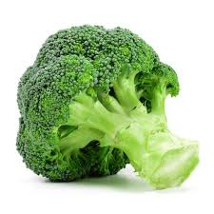
Some people say they love the taste of broccoli, while others, like me- think it’s bitter. But whatever we think of this vegetable, experts agree that it’s healthy. 1… fact, they say it’s really good for us.
Experts are trying to decide whether or 2 … broccoli is a ‘superfood’- a food which is especially good for our bodies. This hasn’t been decided yet, but the list of benefits broccoli provides is pretty amazing. That’s because, like lots of other green vegetables, it’s full of good things. The say that as long 3 … we eat plenty of it, broccoli is probably able 4 … reduce heart disease, keep our bones strong and help our eyesight.
One question that 5… often asked by people like me about vegetables like broccoli is, ‘Are they better for us when they are cooked or raw?’ Research shows that 6 … method of cooking broccoli is fine – it’s the quantity that is important.

The word you need means that both raw and cooked broccoli is OK.

NOW GO ONLINE

CLICK AND WORK ONLINE:
SKILLS 4: https://forms.gle/wNSXZ2FpryatJjfm9

PLEASE PRESS “SUBMIT/SEND” AT THE END OF YOUR ONLINE WORK
POR FAVOR PRESIONAR “ENVIAR” AL FINAL DEL TRABAJO EN LINEA
This is the end of your file. Check you have solved all the activities, save your work and send it to your teacher via email:
Ezequiel: mrlavena7th@gmail.com
Gisela: msgisela7th@gmail.com
Florencia: msflorz7th@gmail.com
Camila: mscamila7th@gmail.com

