Name: … | Surname: …
Home Schooling 20

Reading
Read the following attentively:
A. World Car Free Day
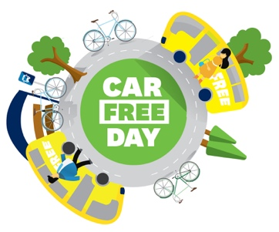
The motor car first appeared on the streets in 1886. Today, there are more than one billion cars around the globe. They produce noise and pollution. On September 22nd Car Free Day invites people to leave their cars at home and use their bikes or public transport or simply to walk to reduce carbon emissions. There were informal car free days in the 1990s, but the first official global Car Free Day was in 2000. Many big cities, like Bogota and Jakarta, close their central roads on this day and organize walking and cycling events, and smaller car-free events which take place around the world.

B. International Walk to School Day
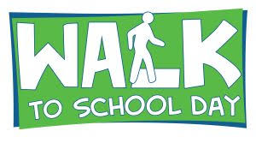
More than 40 countries participate in this event in October every year. Children, parents, teachers and everybody in the education community together with community leaders walk and bike to school. International Walk to School Day began in 1997 as a one-day event. This year International Walk to School Day was on October 10th.

C. World Water Day
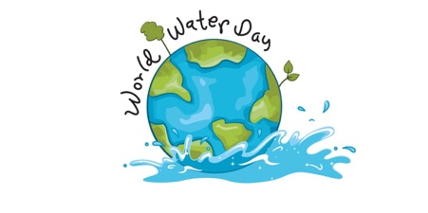
The first World Water Day was in 1993. The United Nations designated March 22nd as World Water Day. On this date there are all kinds of events: education, theatre, music events. There are also campaigns to get money for water projects. Each year more and more countries celebrate it.

After reading decide which event these comments refer to. Sometimes more than one answer is possible. Fill the gaps with the correct letter, A, B, or C.

On this date…
- Members of the community get together in the streets. …
- You can see actors putting on a show. …
- We have to look for answers to problems in nature. …
- Streets are not noisy. …
- The air is cleaner. …
- There isn’t heavy traffic. …
- You can go to music or dance festivals. …
- The focus on the event is not always the same …

Writing: What do you think?

Choose one of the slogans and write your reflection in about 100 words. You can use the questions below to help you.
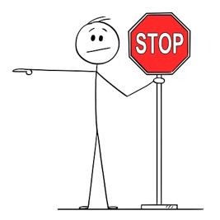
WRITING TIPS!

- Remember to use the tenses we have learnt.
- Try to use the vocabulary you know and you learnt.
- Use anecdotes and personal experiences.
CHECK

- Spelling mistakes
- Tenses
- Vocabulary
- Punctuation

Don’t use informal vocabulary (‘cause, 4, LOL).

- What do you think about these quotations and slogans?
- How can you relate to these ideas?
- What can you do to protect our planet?
- When did you start protecting the planet?
- What are you doing to help the environment?
“The Earth is what we all have in common.” Wendell Berry
“Reduce, Reuse, Recycle.”
“Pollution —if you don’t kill it, it will kill you.”
“With water we give life to everything.”
“Be the change you want to see in the world.” Mahatma Gandhi
“He that plants trees loves others besides himself.” Thomas Fuller

…

This is the end of your file. Check you have solved all the activities, save your work and send it to your teacher via email:
Ezequiel: mrlavena7th@gmail.com
Gisela: msgisela7th@gmail.com
Florencia: msflorz7th@gmail.com
Camila: mscamila7th@gmail.com

