Name: … Surname: …
Home Schooling 21
The Future is now!

CLICK TO WATCH THE FOLLOWING PRESENTATION ON FUTURE FORMS
https://learnenglishteens.britishcouncil.org/grammar/intermediate-grammar/future-forms

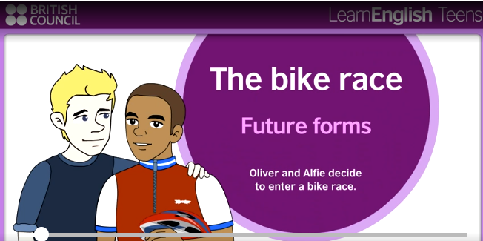

Complete the conversation between two brothers with the correct form of the verbs in brackets. Use will or going to.
A: | Where are you going, Tim?
B: | To the computer shop. I … (buy) a new game.
A: | I’m bored. I … (come) with you.
B: | OK. The game I want is quite new, so it … (not take) long to find it.
B: | Ah, here it is. There’s no price on it. Excuse me, how much is this?
C: | Let me check. This one’s forty-five euros but we … (have) a sale soon, so it … (probably/be) cheaper then.
B: | Thanks! I … (not buy) it today, then.
A: | I … (meet) my friend in town next weekend. I can get it for you then if you like.
B: | Oh that would be great – thanks, Jon!  NOW GO ONLINE
CLICK AND WORK ONLINE:

GRAMMAR: https://forms.gle/Roo95LsKQZf8xpfV8

READING: https://forms.gle/vsgrvvRpPxfU6TC68

LISTENING: https://forms.gle/RmeG95daPPjBD7BN8

PLEASE PRESS “SUBMIT/SEND” AT THE END OF YOUR ONLINE WORK
POR FAVOR PRESIONAR “ENVIAR” AL FINAL DEL TRABAJO EN LINEA
This is the end of your file. Check you have solved all the activities, save your work and send it to your teacher via email:
Ezequiel: mrlavena7th@gmail.com
Gisela: msgisela7th@gmail.com
Florencia: msflorz7th@gmail.com
Camila: mscamila7th@gmail.com

