Name: … Surname: …
Home Schooling 22 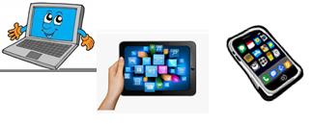
Picture description: Writing
Look at the picture in detail and using the Useful language you worked on (click here: https://bit.ly/2WRuKqC ), write a 100-word description of the photo below.
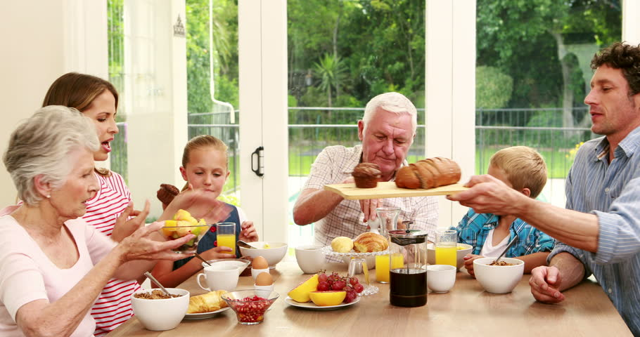
…

NOW GO ONLINE

CLICK AND WORK ONLINE:
SKILLS 5: https://forms.gle/GHLkjcYhJztcfD9c6

PLEASE PRESS “SUBMIT/SEND” AT THE END OF YOUR ONLINE WORK
POR FAVOR PRESIONAR “ENVIAR” AL FINAL DEL TRABAJO EN LINEA
This is the end of your file. Check you have solved all the activities, save your work and send it to your teacher via email:
Ezequiel: mrlavena7th@gmail.com
Gisela: msgisela7th@gmail.com
Florencia: msflorz7th@gmail.com
Camila: mscamila7th@gmail.com

