Name: … Surname: …
Home Schooling 23 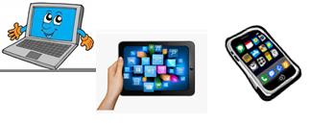
GO ONLINE

CLICK AND WORK ONLINE:

VOCABULARY: https://forms.gle/b73UiRmNg86Xn7r37

GRAMMAR: https://forms.gle/kP1KZmsk3QAwCuCSA

READING: https://forms.gle/M1c5Dtnr7Sb6QYNm8

PLEASE PRESS “SUBMIT/SEND” AT THE END OF YOUR ONLINE WORK
POR FAVOR PRESIONAR “ENVIAR” AL FINAL DEL TRABAJO EN LINEA

