Name: … Surname: …
Home Schooling 24
Important!!!
Do the Email writing part of Home Schooling 24 AFTER this week’s Zoom Class
Email Writing
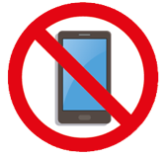
National Unplugged Day

This year’s ‘Unplugged’ Day will be on Friday 22 November.
Each person gives up a gadget for the whole day.
What are you going to give up: your mobile phone, tablet, TV, games console or something else?

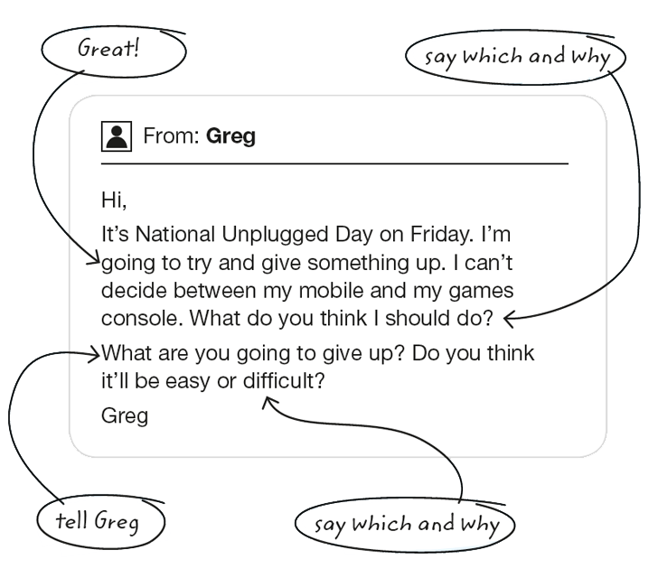
- Read this e-mail from Greg.

Now, answer:
- Which gadget should Greg give up? Why? …
- What are you going to give up? Why? …
- Will it be easy or difficult? Why? …

- Write your reply to Greg in about 100 words. Include your answers from the previous exercise.

Remember to use the following phrases to give advice and/or make a suggestion to Greg (You should …/ You ought to …/ Why don’t you… ?/ You could…/ How about…?)

From: … | To: Greg
…

CHECK
- Spelling mistakes
- Tenses
- Vocabulary
- Punctuations marks
- Capital letters

NOW GO ONLINE

CLICK AND WORK ONLINE:
SKILLS 6: https://forms.gle/R5jUxeQvNycrE4Dg9

PLEASE PRESS “SUBMIT/SEND” AT THE END OF YOUR ONLINE WORK
POR FAVOR PRESIONAR “ENVIAR” AL FINAL DEL TRABAJO EN LINEA
This is the end of your file. Check you have solved all the activities, save your work and send it to your teacher via email:
Ezequiel: mrlavena7th@gmail.com
Gisela: msgisela7th@gmail.com
Florencia: msflorz7th@gmail.com
Camila: mscamila7th@gmail.com

