Name: … Surname: …
Home Schooling 26 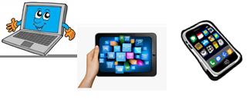

Read the following activities carefully and think about them. You will work on them at this week’s Zoom class.

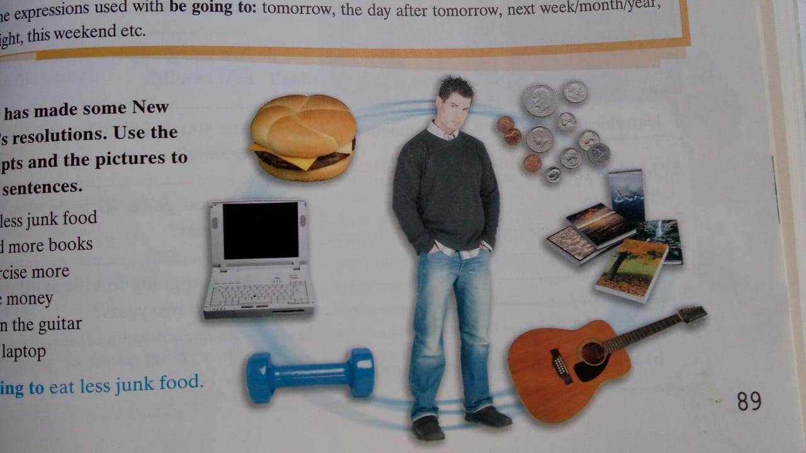
1 Tony has made some New Year’s resolutions. Use the prompts and the pictures to make sentences.

- Eat less junk food
- Read more books
- Exercise more
- Save money
- Learn play the guitar
- Buy laptop

2 Match the sentences 1 to 8 with the answers A to H
YOU SAY… |  | RESPONSE
1 The phone ‘s ringing. |  | A I’ll lend you some.
2 I can’t do my homework |  | B I’ll buy him a card.
3 It’s very hot in here. |  | C I’ll answer it.
4 It’s a secret. |  | D Shall I turn on the light?
5 It’s Paul’s birthday tomorrow |  | E I’ll help you
6 You left the door open. |  | F Shall I open the window?
7 I don’t have any money. |  | G I’ll close it
8 It’s very dark in here. |  | H I won’t tell anybody.

3 Imagine you are going on a trip to the Moon for two weeks. Here are some things you can take with you. Discuss which things will be useful on the trip and which won’t. Use the words and phrases below.
Useful
phrases
Expressing an opinion

I (don’t) think we’ll need …
Maybe we should take …
A(n) … is(n’t) going to be very useful…
A(n) will/ won’t be very useful …
I’m/ We’re definitely taking …
We’ll/ We won’t be able to use …

Giving reasons and results

…because …
… as …
… since …
One/ The main reason is that …
Because of this, … so …

You can take other things with you. What are you going to take and why?

