Name: … Surname: …
Home Schooling 37

1 Listen to eight sentences. Write the past participle you hear in each sentence. Click here: https://bit.ly/2ApL0rr

- started
- …
- …
- …
- …
- …
- …
- …

2 Complete the sentences with the past simple or present perfect form of the verbs in brackets.

1 Karen’s excited about buying a skateboard. She … (want) one for a long time.
2 Luke … (have) a difficult time when he was at his old school.
3 I … (not see) Sophie today at all. Do you know where she is?
4 James … (annoy) Tom and they ‘re not talking to each other now.
5 We … (be) bored yesterday because we didn’t have anything to do.
6 I’m not going to enter the 100 m race. I … (not do) enough training for it.
7 Unfortunately, they … (not win) the game last week.
8 He … (break) his leg, so he can’t play next week.
9 Eric … (be) in our team since January. He’s one of our best players.
10 Amanda … (come) third in the swimming competition on Saturday.

3 Read the blog post and for each question, write the correct answer. Write one word for each gap.
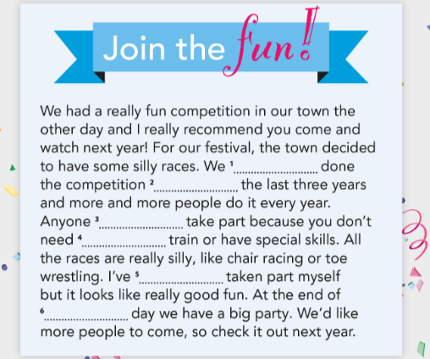
…
…

…

…

…

…

…

GO ONLINE

CLICK AND WORK ONLINE:

https://forms.gle/gRDhKTgA14ioSRLx8

PLEASE PRESS “SUBMIT/SEND” AT THE END OF YOUR ONLINE WORK
POR FAVOR PRESIONAR “ENVIAR” AL FINAL DEL TRABAJO EN LÍNEA

This is the end of your file. Check you have solved all the activities, save your work and send it to your teacher via email:
Ezequiel: mrlavena7th@gmail.com
Gisela: msgisela7th@gmail.com
Florencia:msflorz7th@gmail.com
Camila:mscamila7th@gmail.com

