Name: … Surname: …
Home Schooling 38
Switch On
SPORTS

- What sports do you play? Why do you play them?
…
- If you don’t play sports, why not? Is it because you don’t enjoy them or because you don’t have the opportunity?
…

- Watch the clip about young people who play a sport.
Click here: https://drive.google.com/file/d/1sRcWWAwUMK2VNpVOd4hrlDfqfNIYXTMA/view?usp=sharing
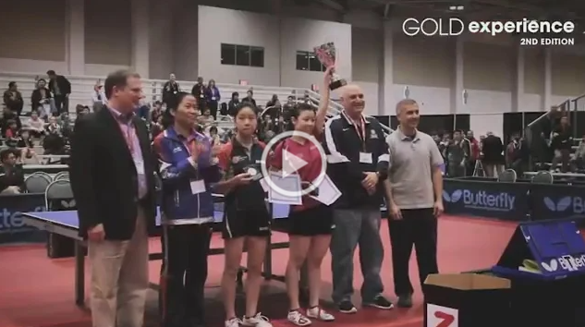
Which sport is it? Would you like to play it? Why/Why not?
…

- Watch again. Are these sentences True (T) or False (F)?

- Aerial’s dad has quit his job to coach her full time. …
- Lily doesn’t have a social life – she only plays table tennis. …
- Lily doesn’t care about school. …
- Michael studies from home. …
- Chinese table tennis players train for fourteen hours a day. …

- What are the advantages and disadvantages of practising and playing a sport at a professional level as a teenager?
…

Skills 11B:
Listening: Look at the notes about the Berkshire Half Marathon. Some information is missing.
You will hear a presenter talking on the radio about the race.
Fill in the numbered gaps with a phrase, a number or a date.
Press ctrl and click to listen to the audio file:
https://bit.ly/31JYDgf
Berkshire Half Marathon
Date: Sunday 10th (1) …
Race start time: (2) …
Place: Rivermead Leisure Complex
Facilities at Rivermead include:
Place to leave bags
Free massage
Toilets
(3) …
The course is traffic-free and controlled by
Thames Valley police.
Facilities during the course include:
Water, sponge and drinks stations
First aid
Public support
Live (4) …
About the marathon
Age group: 10-16 year olds
Distance: one mile
First prize: (5) …
To enter, go to the website or ask for an entry (6) …

Entries to be received by Friday 8th March

This is the end of your file. Check you have solved all the activities, save your work and send it to your teacher via email:
Ezequiel: mrlavena7th@gmail.com
Gisela: msgisela7th@gmail.com
Florencia:msflorz7th@gmail.com
Camila:mscamila7th@gmail.com

