Name: … Surname: …
Home Schooling 39

1 Make sentences in the present perfect.
1 I/ play/ in a lot of football games this term.
…
2 our team/ not win/ any matches this year.
…
3 I not try/ mud running, but I’d like to.
…
4 you/ put/ your clothes in your locker?
…
5 Jacob/ start/ learning kickboxing with the new coach.
…
6 the school/ buy/ some new footballs.
…
2 Use the information in the table to write a paragraph about Jack and Amelia. Use the present perfect and already or yet.
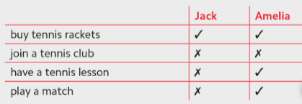

Jack and Amelia have decided to get fit. They have already …
They haven’t …
Jack hasn’t…
Amelia has already …
Jack hasn’t …
Amelia …
GO ONLINE

CLICK AND WORK ONLINE:
https://forms.gle/jCjc3iQ2FeEMVHpp6
Skills 12: https://forms.gle/rxigR6QPnhb3USLz9

PLEASE PRESS “SUBMIT/SEND” AT THE END OF YOUR ONLINE WORK
POR FAVOR PRESIONAR “ENVIAR” AL FINAL DEL TRABAJO EN LÍNEA

This is the end of your file. Check you have solved all the activities, save your work and send it to your teacher via email:
Ezequiel: mrlavena7th@gmail.com
Gisela: msgisela7th@gmail.com
Florencia:msflorz7th@gmail.com
Camila:mscamila7th@gmail.com

