Name: … | Surname: …
Home Schooling 40

GO
ONLINE
CLICK AND WORK ONLINE:
Reading “Hurricane Catrina”:
https://forms.gle/7rgovmqsCgVuUuNM7

PLEASE PRESS “SUBMIT/SEND” AT THE END OF YOUR ONLINE WORK
POR FAVOR PRESIONAR “ENVIAR” AL FINAL DEL TRABAJO EN LÍNEA

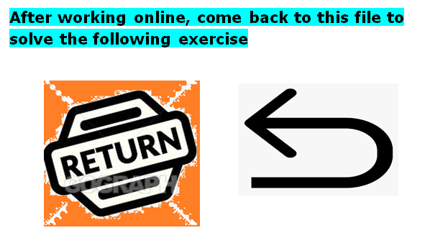

Writing (about 80-100 words)
Imagine Hurricane Katrina has just hit the city of New Orleans and the kids in New Orleans are not going to school. So, a school in the area is inviting other children of the world to write an e-mail to these kids to make them feel better. You have to write an e-mail to Daniel and his sister Emma, who are living in a refuge with their family because they have lost their house and the school where they used to go does not exist anymore. Include in your e-mail:

- who you are, and where you are from;
- what games they can play to spend their time;
- or what music they can listen to to feel happy;
- a message for their family hoping that everything will be alright.

From: … | To: Daniel and Emma
…

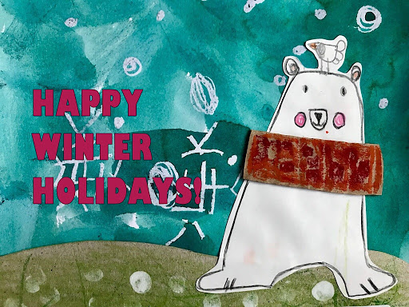

This is the end of your file. Check you have solved all the activities, save your work and send it to your teacher via email:
Ezequiel: mrlavena7th@gmail.com
Gisela: msgisela7th@gmail.com
Florencia: msflorz7th@gmail.com
Camila: mscamila7th@gmail.com

