Name: … Surname: …
Home Schooling 42 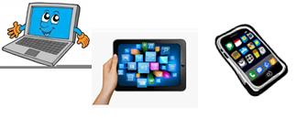
GO
ONLINE

CLICK AND WORK ONLINE:
Reading:
https://forms.gle/mSkGfcM8PXajCBtn6
Vocabulary:
https://forms.gle/orn6rm8ecWWBUCSy7
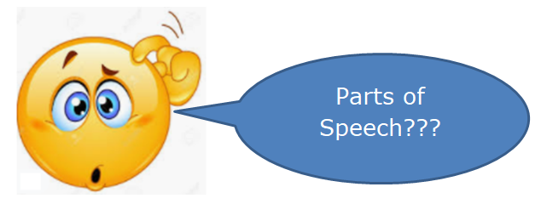

PLEASE PRESS “SUBMIT/SEND” AT THE END OF YOUR ONLINE WORK
POR FAVOR PRESIONAR “ENVIAR” AL FINAL DEL TRABAJO EN LÍNEA

